NOR-SOLIDARITY First Interim Report

Inge Christoffer Olsen, PhD

04 January, 2021

Table of Contents

2 Introduction 3

3 Inclusion status 4

3.1 Inclusion rate 4

3.2 Inclusion by hospital 5

3.3 By treatment 6

4 Patient flow 10

5 Demographics 11

6 Exposure 25

7 Efficacy 25

7.1 Mortality 25

7.1.1 Descriptives 25

7.1.2 Plots 27

7.1.3 Efficacy estimates 36

7.2 Viral load 38

7.2.1 Plots 38

7.2.2 Marginal probability estimates by treatment group and difference 42

7.3 Viral load subgroup analyses 44

7.3.1 Plots, Hydroxychloroquine 44

7.3.2 Marginal probability estimates by treatment group and difference Hydroxychloroquine 56

7.3.3 Plots Remdesivir 61

7.3.4 Marginal probability estimates by treatment group and difference Remdesivir 73

7.4 Respiratory failure by pO2/FiO2-ratio 78

7.4.1 Plots 78

7.4.2 Marginal probability estimates by treatment group and difference 82

7.5 Dichotomous endpoints 83

7.5.1 Descriptives 83

7.5.2 Marginal probability estimates by treatment group and difference 85

7.6 Inflammatory laboratory parameters 86

7.6.1 Descriptives 86

7.6.2 Plots 110

7.6.3 Efficacy estimates 122

7.7 SARS-CoV2 antibodies at day 90 127

7.7.1 Descriptives 127

7.7.2 Marginal probability estimates by treatment group and difference 128

7.8 Time to last discharge 129

7.8.1 HCQ 129

7.8.2 Remdesivir 132

8 Adverse Events 135

8.1 AE Summary 135

8.2 By System Organ Class and Preferred Term 135

8.3 Serious Adverse Events 140

8.4 Suspected Unexpected Serious Adverse Reaction 142

# Introduction

This is the report for the first interim analysis of the NOR-SOLIDARITY trial. The data are based on an export from the Viedoc electronic data capture at “2020-10-16 08:41:09” system time stamped “ous_20201016_084109”. While the results are based on real data, the treatment allocation has been drawn randomly for this report. Thus, this is a mock-up report intended to show how the final report will look like, without showing the actual results of the trial and the treatment differences. There were 181 included patients.

# Inclusion status

## Inclusion rate

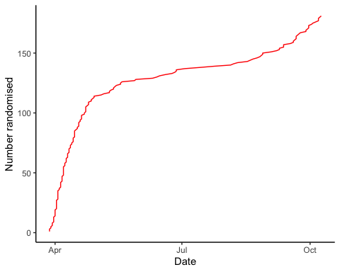

## Inclusion by hospital

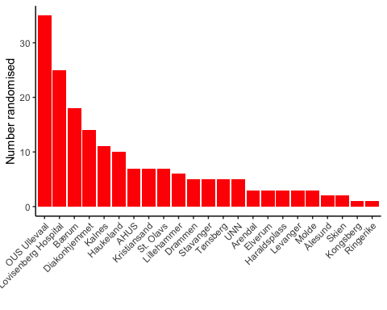

## By treatment

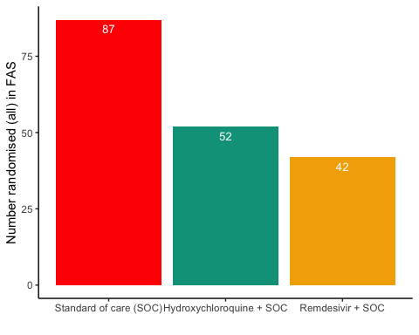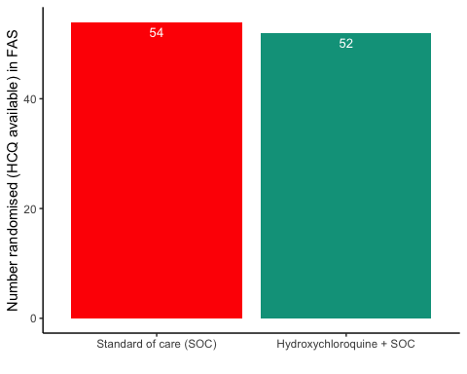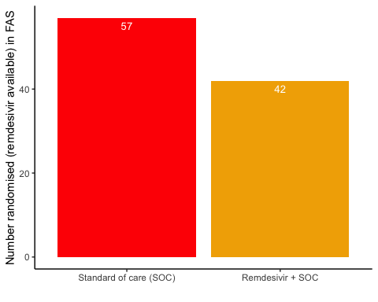

# Patient flow

## Note: Using an external vector in selections is ambiguous.  
## ℹ Use `all_of(group)` instead of `group` to silence this message.  
## ℹ See <https://tidyselect.r-lib.org/reference/faq-external-vector.html>.  
## This message is displayed once per session.

Patient flow total

|  |  |
| --- | --- |
| Parameter | Total |
| Enrolled | 186 (100%) |
| Randomised | 185 (99.5%) |
| Included in FAS | 181 (97.3%) |
| Excluded from FAS, No post-randomisation information | 4 (2.2%) |
| Excluded from FAS, incorrect inclusion | 1 (0.5%) |

Patient flow by arm

|  |  |  |  |
| --- | --- | --- | --- |
| Parameter | SOC | SOC + HCQ | SOC + Remdesivir |
| Randomised | 88 (100%) | 54 (100%) | 43 (100%) |
| Included in FAS | 87 (98.9%) | 52 (96.3%) | 42 (97.7%) |
| Excluded from FAS, No post-randomisation information | 1 (1.1%) | 1 (1.9%) | 1 (2.3%) |
| Excluded from FAS, incorrect inclusion | 0 (0%) | 1 (1.9%) | 0 (0%) |

Patient flow during study (FAS)

|  |  |  |  |  |
| --- | --- | --- | --- | --- |
| Reason | Standard of care (SOC) | Remdesivir + SOC | Hydroxychloroquine + SOC | Total |
| Voluntary discontinuation by the patient | 3 | 4 | 0 | 7 |
| Patient lost to follow-up | 2 | 2 | 2 | 6 |
| Death | 2 | 5 | 5 | 12 |
| Other | 4 | 2 | 0 | 6 |
| Completed | 76 | 29 | 45 | 150 |

# Demographics

Demographics, all patients (FAS)

|  |  |
| --- | --- |
| Parameter | All patients (N=181) |
| **Demographics** |  |
| Age (years) | 59.8 (15.3) |
| Female, n (%) | 62 (34.3%) |
| Body Mass Index (kg/m2) | 28 (5) |
| Body Mass Index (kg/m2) | 27 (25 - 31) |
| Symptoms prior to admission (days) | 8 (4.9) |
| P/F-ratio at admittance (kPa) | 41 (13) |
| P/F-ratio < 40kPa, n (%) | 77 (43%) |
| Temperature (°C) | 37.4 (0.9) |
| Admitted to ward, n(%) | 171 (94.5%) |
| Admitted to ICU, n(%) | 10 (5.5%) |
| WHO Moderate disease state (4-5), n(%) | 171 (94.5%) |
| WHO Severe disease state (6-9), n(%) | 10 (5.5%) |
| WHO Severe disease state (6), n(%) | 5 (2.8%) |
| WHO Severe disease state (5), n(%) | 90 (49.7%) |
| **Comorbidities** |  |
| Chronic cardiac disease, including congenital heart disease | 28 (15.6%) |
| Chronic pulmonary disease, n(%) | 10 (5.6%) |
| Ever smoking, n(%) | 71 (39.4%) |
| Hypertension, n(%) | 55 (30.6%) |
| Diabetes, n(%) | 31 (17.2%) |
| Obese (BMI > 30 kg/m2), n(%) | 44 (26.8%) |
| **Co-medications** |  |
| Steroids | 8 (4.5%) |
| Other immunomodulatory drugs | 8 (4.5%) |
| ACE inhibitor | 12 (6.7%) |
| AT-II blockers | 30 (16.8%) |
| **Hematology** |  |
| Hemoglobin (g/dL) | 13.2 (12.3 - 14.1) |
| WBC (x109/L) | 6.2 (4.7 - 8.7) |
| Neutrophils (x109/L) | 4.3 (3 - 6.6) |
| Lymphocytes (x109/L) | 1.1 (0.8 - 1.4) |
| Platelet counts (x10^9/L) | 202.5 (158.5 - 270.5) |
| **Inflammatory markers** |  |
| CRP (mg/L) | 70 (36.5 - 137.5) |
| Procalcitonin (µg/L) | 0.12 (0.1 - 0.21) |
| Ferritin (µg/L) | 613 (319 - 1173) |
| **Other** |  |
| LDH (U/L) | 277 (214 - 360) |
| D-dimer (mg/L FEU) | 0.68 (0.45 - 1.12) |
| AST | 39 (27.2 - 59) |
| ALT | 33 (20 - 58) |
| eGFR (mL/min/1.73 m2) | 89.7 (74.2 - 105.5) |
| **Viral count** |  |
| Viral count (log10 counts/1000 cells) | 2 (1.6) |
| **Anti-SARS-CoV-2 Antibodies** |  |
| **Supplementary baseline information** |  |
| Systolic Blood Pressure (mmHg) | 125 (18) |
| Diastolic Blood Pressure (mmHg) | 74 (11) |
| Mean Arterial Blood Pressure (mmHg) | 91 (12) |
| SOFA score | 1.6 (1.6) |
| Chronic kidney disease, n(%) | 11 (6.1%) |
| Autoimmune disease, n(%) | 8 (4.4%) |
| Cognitive impairment/dementia, n(%) | 4 (2.2%) |
| Neurological disorder, n(%) | 7 (3.9%) |
| Cancer, n(%) | 13 (7.2%) |
| Cirrhosis, n(%) | 0 (0%) |
| Asthma, n(%) | 22 (12.2%) |
| HIV, n(%) | 0 (0%) |
| Active TB, n(%) | 0 (0%) |
| Note, all percentages are given with observed values in the denominator, missing values discarded |  |

Demographics, all arms (FAS)

|  |  |  |  |
| --- | --- | --- | --- |
| Parameter | SOC (N=87) | SOC + HCQ (N=52) | SOC + Remdesivir (N=42) |
| **Demographics** |  |  |  |
| Age (years) | 58.2 (14.6) | 59.1 (16.7) | 63.8 (14.7) |
| Female, n (%) | 29 (33.3%) | 15 (28.8%) | 18 (42.9%) |
| Body Mass Index (kg/m2) | 29 (5) | 27 (4) | 27 (5) |
| Body Mass Index (kg/m2) | 28 (25 - 33) | 27 (24 - 29) | 27 (25 - 29) |
| Symptoms prior to admission (days) | 8 (4.9) | 7.3 (4.7) | 9 (5.2) |
| P/F-ratio at admittance (kPa) | 42 (12) | 43 (13) | 38 (15) |
| P/F-ratio < 40kPa, n (%) | 37 (43%) | 20 (39.2%) | 20 (47.6%) |
| Temperature (°C) | 37.3 (1) | 37.5 (0.9) | 37.5 (0.9) |
| Admitted to ward, n(%) | 84 (96.6%) | 49 (94.2%) | 38 (90.5%) |
| Admitted to ICU, n(%) | 3 (3.4%) | 3 (5.8%) | 4 (9.5%) |
| WHO Moderate disease state (4-5), n(%) | 83 (95.4%) | 49 (94.2%) | 39 (92.9%) |
| WHO Severe disease state (6-9), n(%) | 4 (4.6%) | 3 (5.8%) | 3 (7.1%) |
| WHO Severe disease state (6), n(%) | 2 (2.3%) | 2 (3.8%) | 1 (2.4%) |
| WHO Severe disease state (5), n(%) | 41 (47.1%) | 24 (46.2%) | 25 (59.5%) |
| **Comorbidities** |  |  |  |
| Chronic cardiac disease, including congenital heart disease | 13 (15.1%) | 9 (17.3%) | 6 (14.3%) |
| Chronic pulmonary disease, n(%) | 3 (3.5%) | 4 (7.7%) | 3 (7.1%) |
| Ever smoking, n(%) | 34 (39.5%) | 22 (42.3%) | 15 (35.7%) |
| Hypertension, n(%) | 24 (27.9%) | 18 (34.6%) | 13 (31%) |
| Diabetes, n(%) | 13 (15.1%) | 7 (13.5%) | 11 (26.2%) |
| Obese (BMI > 30 kg/m2), n(%) | 26 (32.5%) | 10 (22.7%) | 8 (20%) |
| **Co-medications** |  |  |  |
| Steroids | 3 (3.5%) | 3 (5.9%) | 2 (4.8%) |
| Other immunomodulatory drugs | 3 (3.5%) | 3 (5.9%) | 2 (4.8%) |
| ACE inhibitor | 6 (7%) | 3 (5.9%) | 3 (7.1%) |
| AT-II blockers | 13 (15.1%) | 7 (13.7%) | 10 (23.8%) |
| **Hematology** |  |  |  |
| Hemoglobin (g/dL) | 13.1 (12.1 - 14.1) | 13.6 (13 - 14.4) | 12.9 (11.6 - 14) |
| WBC (x109/L) | 6.3 (4.5 - 9) | 6.2 (4.8 - 8.1) | 6 (4.8 - 7.9) |
| Neutrophils (x109/L) | 4.5 (2.8 - 7) | 4.6 (3 - 6.4) | 3.9 (3.2 - 5.6) |
| Lymphocytes (x109/L) | 1.1 (0.8 - 1.3) | 1.1 (0.8 - 1.4) | 1.1 (0.7 - 1.5) |
| Platelet counts (x10^9/L) | 204 (151.2 - 268.2) | 197 (163 - 268.8) | 208.5 (170.2 - 271.2) |
| **Inflammatory markers** |  |  |  |
| CRP (mg/L) | 70.5 (40.8 - 138.8) | 75 (43 - 137.8) | 61 (27 - 127) |
| Procalcitonin (µg/L) | 0.12 (0.1 - 0.2) | 0.12 (0.1 - 0.2) | 0.15 (0.1 - 0.39) |
| Ferritin (µg/L) | 626 (321.5 - 1116) | 578 (315.2 - 1209.5) | 573 (316 - 1194) |
| **Other** |  |  |  |
| LDH (U/L) | 279 (216 - 368) | 290 (216 - 353.5) | 274 (209 - 325) |
| D-dimer (mg/L FEU) | 0.6 (0.41 - 1.18) | 0.64 (0.5 - 1.02) | 0.9 (0.51 - 1.12) |
| AST | 41 (29 - 57) | 43 (27 - 65) | 32.5 (24 - 61.2) |
| ALT | 39 (22 - 61) | 30 (22.5 - 58.5) | 23.5 (18.2 - 49) |
| eGFR (mL/min/1.73 m2) | 91.6 (79.8 - 106) | 88.8 (76.1 - 104.6) | 83.3 (67.8 - 97.3) |
| **Viral count** |  |  |  |
| Viral count (log10 counts/1000 cells) | 1.9 (1.6) | 2.1 (1.7) | 2.2 (1.5) |
| **Anti-SARS-CoV-2 Antibodies** |  |  |  |
| **Supplementary baseline information** |  |  |  |
| Systolic Blood Pressure (mmHg) | 125 (18) | 125 (17) | 125 (18) |
| Diastolic Blood Pressure (mmHg) | 73 (11) | 74 (12) | 73 (12) |
| Mean Arterial Blood Pressure (mmHg) | 91 (12) | 91 (12) | 91 (12) |
| SOFA score | 1.8 (1.8) | 1.3 (1.4) | 1.5 (1.5) |
| Chronic kidney disease, n(%) | 5 (5.8%) | 2 (3.8%) | 4 (9.5%) |
| Autoimmune disease, n(%) | 3 (3.5%) | 3 (5.8%) | 2 (4.8%) |
| Cognitive impairment/dementia, n(%) | 2 (2.3%) | 1 (1.9%) | 1 (2.4%) |
| Neurological disorder, n(%) | 3 (3.5%) | 3 (5.8%) | 1 (2.4%) |
| Cancer, n(%) | 6 (7%) | 6 (11.5%) | 1 (2.4%) |
| Cirrhosis, n(%) | 0 (0%) | 0 (0%) | 0 (0%) |
| Asthma, n(%) | 6 (7%) | 11 (21.2%) | 5 (11.9%) |
| HIV, n(%) | 0 (0%) | 0 (0%) | 0 (0%) |
| Active TB, n(%) | 0 (0%) | 0 (0%) | 0 (0%) |
| Note, all percentages are given with observed values in the denominator, missing values discarded |  |  |  |

Demographics, HCQ (FAS)

|  |  |  |
| --- | --- | --- |
| Parameter | SOC (N=54) | SOC + HCQ (N=52) |
| **Demographics** |  |  |
| Age (years) | 57.4 (16.4) | 59.1 (16.7) |
| Female, n (%) | 17 (31.5%) | 15 (28.8%) |
| Body Mass Index (kg/m2) | 28 (5) | 27 (4) |
| Body Mass Index (kg/m2) | 28 (25 - 31) | 27 (24 - 29) |
| Symptoms prior to admission (days) | 8.1 (5.5) | 7.3 (4.7) |
| P/F-ratio at admittance (kPa) | 40 (11) | 43 (13) |
| P/F-ratio < 40kPa, n (%) | 25 (46.3%) | 20 (39.2%) |
| Temperature (°C) | 37.2 (1) | 37.5 (0.9) |
| Admitted to ward, n(%) | 52 (96.3%) | 49 (94.2%) |
| Admitted to ICU, n(%) | 2 (3.7%) | 3 (5.8%) |
| WHO Moderate disease state (4-5), n(%) | 52 (96.3%) | 49 (94.2%) |
| WHO Severe disease state (6-9), n(%) | 2 (3.7%) | 3 (5.8%) |
| WHO Severe disease state (6), n(%) | 1 (1.9%) | 2 (3.8%) |
| WHO Severe disease state (5), n(%) | 30 (55.6%) | 24 (46.2%) |
| **Comorbidities** |  |  |
| Chronic cardiac disease, including congenital heart disease | 8 (15.1%) | 9 (17.3%) |
| Chronic pulmonary disease, n(%) | 1 (1.9%) | 4 (7.7%) |
| Ever smoking, n(%) | 22 (41.5%) | 22 (42.3%) |
| Hypertension, n(%) | 14 (26.4%) | 18 (34.6%) |
| Diabetes, n(%) | 9 (17%) | 7 (13.5%) |
| Obese (BMI > 30 kg/m2), n(%) | 14 (29.2%) | 10 (22.7%) |
| **Co-medications** |  |  |
| Steroids | 2 (3.8%) | 3 (5.9%) |
| Other immunomodulatory drugs | 2 (3.8%) | 3 (5.9%) |
| ACE inhibitor | 2 (3.8%) | 3 (5.9%) |
| AT-II blockers | 9 (17%) | 7 (13.7%) |
| **Hematology** |  |  |
| Hemoglobin (g/dL) | 13 (12.1 - 14.1) | 13.6 (13 - 14.4) |
| WBC (x109/L) | 6.6 (4.9 - 9.2) | 6.2 (4.8 - 8.1) |
| Neutrophils (x109/L) | 4.8 (3 - 7.4) | 4.6 (3 - 6.4) |
| Lymphocytes (x109/L) | 1.1 (0.8 - 1.5) | 1.1 (0.8 - 1.4) |
| Platelet counts (x10^9/L) | 217 (160 - 288.8) | 197 (163 - 268.8) |
| **Inflammatory markers** |  |  |
| CRP (mg/L) | 70.5 (40.8 - 137) | 75 (43 - 137.8) |
| Procalcitonin (µg/L) | 0.15 (0.1 - 0.25) | 0.12 (0.1 - 0.2) |
| Ferritin (µg/L) | 677 (312.2 - 1049.5) | 578 (315.2 - 1209.5) |
| **Other** |  |  |
| LDH (U/L) | 280 (220.8 - 358.8) | 290 (216 - 353.5) |
| D-dimer (mg/L FEU) | 0.6 (0.43 - 1.15) | 0.64 (0.5 - 1.02) |
| AST | 39.5 (28.8 - 58.2) | 43 (27 - 65) |
| ALT | 40.5 (22.2 - 63.8) | 30 (22.5 - 58.5) |
| eGFR (mL/min/1.73 m2) | 95.7 (83.2 - 106.1) | 88.8 (76.1 - 104.6) |
| **Viral count** |  |  |
| Viral count (log10 counts/1000 cells) | 1.8 (1.6) | 2.1 (1.7) |
| **Anti-SARS-CoV-2 Antibodies** |  |  |
| **Supplementary baseline information** |  |  |
| Systolic Blood Pressure (mmHg) | 128 (19) | 125 (17) |
| Diastolic Blood Pressure (mmHg) | 75 (10) | 74 (12) |
| Mean Arterial Blood Pressure (mmHg) | 93 (11) | 91 (12) |
| SOFA score | 1.7 (1.8) | 1.3 (1.4) |
| Chronic kidney disease, n(%) | 2 (3.8%) | 2 (3.8%) |
| Autoimmune disease, n(%) | 2 (3.8%) | 3 (5.8%) |
| Cognitive impairment/dementia, n(%) | 1 (1.9%) | 1 (1.9%) |
| Neurological disorder, n(%) | 0 (0%) | 3 (5.8%) |
| Cancer, n(%) | 3 (5.7%) | 6 (11.5%) |
| Cirrhosis, n(%) | 0 (0%) | 0 (0%) |
| Asthma, n(%) | 5 (9.4%) | 11 (21.2%) |
| HIV, n(%) | 0 (0%) | 0 (0%) |
| Active TB, n(%) | 0 (0%) | 0 (0%) |
| Note, all percentages are given with observed values in the denominator, missing values discarded |  |  |

Demographics, Remdesivir (FAS)

|  |  |  |
| --- | --- | --- |
| Parameter | SOC (N=57) | SOC + Remdesivir (N=42) |
| **Demographics** |  |  |
| Age (years) | 56.9 (12.1) | 63.8 (14.7) |
| Female, n (%) | 19 (33.3%) | 18 (42.9%) |
| Body Mass Index (kg/m2) | 29 (5) | 27 (5) |
| Body Mass Index (kg/m2) | 29 (26 - 33) | 27 (25 - 29) |
| Symptoms prior to admission (days) | 8.4 (5.8) | 9 (5.2) |
| P/F-ratio at admittance (kPa) | 43 (12) | 38 (15) |
| P/F-ratio < 40kPa, n (%) | 20 (35.7%) | 20 (47.6%) |
| Temperature (°C) | 37.4 (1) | 37.5 (0.9) |
| Admitted to ward, n(%) | 55 (96.5%) | 38 (90.5%) |
| Admitted to ICU, n(%) | 2 (3.5%) | 4 (9.5%) |
| WHO Moderate disease state (4-5), n(%) | 54 (94.7%) | 39 (92.9%) |
| WHO Severe disease state (6-9), n(%) | 3 (5.3%) | 3 (7.1%) |
| WHO Severe disease state (6), n(%) | 2 (3.5%) | 1 (2.4%) |
| WHO Severe disease state (5), n(%) | 23 (40.4%) | 25 (59.5%) |
| **Comorbidities** |  |  |
| Chronic cardiac disease, including congenital heart disease | 8 (14.3%) | 6 (14.3%) |
| Chronic pulmonary disease, n(%) | 3 (5.4%) | 3 (7.1%) |
| Ever smoking, n(%) | 18 (32.1%) | 15 (35.7%) |
| Hypertension, n(%) | 17 (30.4%) | 13 (31%) |
| Diabetes, n(%) | 7 (12.5%) | 11 (26.2%) |
| Obese (BMI > 30 kg/m2), n(%) | 19 (35.8%) | 8 (20%) |
| **Co-medications** |  |  |
| Steroids | 2 (3.6%) | 2 (4.8%) |
| Other immunomodulatory drugs | 2 (3.6%) | 2 (4.8%) |
| ACE inhibitor | 5 (8.9%) | 3 (7.1%) |
| AT-II blockers | 9 (16.1%) | 10 (23.8%) |
| **Hematology** |  |  |
| Hemoglobin (g/dL) | 13.3 (12.1 - 14.1) | 12.9 (11.6 - 14) |
| WBC (x109/L) | 6.6 (4.3 - 8.7) | 6 (4.8 - 7.9) |
| Neutrophils (x109/L) | 3.8 (2.5 - 6.7) | 3.9 (3.2 - 5.6) |
| Lymphocytes (x109/L) | 1.1 (0.8 - 1.3) | 1.1 (0.7 - 1.5) |
| Platelet counts (x10^9/L) | 202 (144 - 263.2) | 208.5 (170.2 - 271.2) |
| **Inflammatory markers** |  |  |
| CRP (mg/L) | 67 (37.5 - 139.2) | 61 (27 - 127) |
| Procalcitonin (µg/L) | 0.1 (0.1 - 0.19) | 0.15 (0.1 - 0.39) |
| Ferritin (µg/L) | 622 (372.8 - 1153) | 573 (316 - 1194) |
| **Other** |  |  |
| LDH (U/L) | 279 (209 - 369) | 274 (209 - 325) |
| D-dimer (mg/L FEU) | 0.6 (0.41 - 1.2) | 0.9 (0.51 - 1.12) |
| AST | 45 (29 - 57.2) | 32.5 (24 - 61.2) |
| ALT | 41 (25.5 - 70) | 23.5 (18.2 - 49) |
| eGFR (mL/min/1.73 m2) | 91.8 (83.1 - 106.6) | 83.3 (67.8 - 97.3) |
| **Viral count** |  |  |
| Viral count (log10 counts/1000 cells) | 2 (1.7) | 2.2 (1.5) |
| **Anti-SARS-CoV-2 Antibodies** |  |  |
| **Supplementary baseline information** |  |  |
| Systolic Blood Pressure (mmHg) | 124 (18) | 125 (18) |
| Diastolic Blood Pressure (mmHg) | 73 (11) | 73 (12) |
| Mean Arterial Blood Pressure (mmHg) | 90 (12) | 91 (12) |
| SOFA score | 1.7 (1.5) | 1.5 (1.5) |
| Chronic kidney disease, n(%) | 3 (5.4%) | 4 (9.5%) |
| Autoimmune disease, n(%) | 2 (3.6%) | 2 (4.8%) |
| Cognitive impairment/dementia, n(%) | 1 (1.8%) | 1 (2.4%) |
| Neurological disorder, n(%) | 3 (5.4%) | 1 (2.4%) |
| Cancer, n(%) | 3 (5.4%) | 1 (2.4%) |
| Cirrhosis, n(%) | 0 (0%) | 0 (0%) |
| Asthma, n(%) | 4 (7.1%) | 5 (11.9%) |
| HIV, n(%) | 0 (0%) | 0 (0%) |
| Active TB, n(%) | 0 (0%) | 0 (0%) |
| Note, all percentages are given with observed values in the denominator, missing values discarded |  |  |

Missing values, all arms (FAS)

|  |  |  |  |
| --- | --- | --- | --- |
| Parameter | SOC (N=87) | SOC + HCQ (N=52) | SOC + Remdesivir (N=42) |
| **Demographics** |  |  |  |
| Age (years) | 0 (0%) | 0 (0%) | 0 (0%) |
| Female, n (%) | 0 (0%) | 0 (0%) | 0 (0%) |
| Body Mass Index (kg/m2) | 7 (8%), 7 (8%) | 8 (15.4%), 8 (15.4%) | 2 (4.8%), 2 (4.8%) |
| Symptoms prior to admission (days) | 1 (1.1%) | 0 (0%) | 0 (0%) |
| P/F-ratio at admittance (kPa) | 1 (1.1%) | 1 (1.9%) | 0 (0%) |
| P/F-ratio < 40kPa, n (%) | 1 (1.1%) | 1 (1.9%) | 0 (0%) |
| Temperature (°C) | 0 (0%) | 0 (0%) | 0 (0%) |
| Admitted to ward, n(%) | 0 (0%) | 0 (0%) | 0 (0%) |
| Admitted to ICU, n(%) | 0 (0%) | 0 (0%) | 0 (0%) |
| WHO Moderate disease state (4-5), n(%) | 0 (0%) | 0 (0%) | 0 (0%) |
| WHO Severe disease state (6-9), n(%) | 0 (0%) | 0 (0%) | 0 (0%) |
| WHO Severe disease state (6), n(%) | 0 (0%) | 0 (0%) | 0 (0%) |
| WHO Severe disease state (5), n(%) | 0 (0%) | 0 (0%) | 0 (0%) |
| **Comorbidities** |  |  |  |
| Chronic cardiac disease, including congenital heart disease | 1 (1.1%) | 0 (0%) | 0 (0%) |
| Chronic pulmonary disease, n(%) | 1 (1.1%) | 0 (0%) | 0 (0%) |
| Ever smoking, n(%) | 1 (1.1%) | 0 (0%) | 0 (0%) |
| Hypertension, n(%) | 1 (1.1%) | 0 (0%) | 0 (0%) |
| Diabetes, n(%) | 1 (1.1%) | 0 (0%) | 0 (0%) |
| Obese (BMI > 30 kg/m2), n(%) | 7 (8%) | 8 (15.4%) | 2 (4.8%) |
| **Co-medications** |  |  |  |
| Steroids | 1 (1.1%) | 1 (1.9%) | 0 (0%) |
| Other immunomodulatory drugs | 1 (1.1%) | 1 (1.9%) | 0 (0%) |
| ACE inhibitor | 1 (1.1%) | 1 (1.9%) | 0 (0%) |
| AT-II blockers | 1 (1.1%) | 1 (1.9%) | 0 (0%) |
| **Hematology** |  |  |  |
| Hemoglobin (g/dL) | 1 (1.1%) | 2 (3.8%) | 0 (0%) |
| WBC (x109/L) | 0 (0%) | 1 (1.9%) | 0 (0%) |
| Neutrophils (x109/L) | 3 (3.4%) | 6 (11.5%) | 1 (2.4%) |
| Lymphocytes (x109/L) | 2 (2.3%) | 6 (11.5%) | 1 (2.4%) |
| Platelet counts (x10^9/L) | 1 (1.1%) | 2 (3.8%) | 0 (0%) |
| **Inflammatory markers** |  |  |  |
| CRP (mg/L) | 1 (1.1%) | 0 (0%) | 1 (2.4%) |
| Procalcitonin (µg/L) | 32 (36.8%) | 14 (26.9%) | 12 (28.6%) |
| Ferritin (µg/L) | 4 (4.6%) | 2 (3.8%) | 3 (7.1%) |
| **Other** |  |  |  |
| LDH (U/L) | 2 (2.3%) | 5 (9.6%) | 1 (2.4%) |
| D-dimer (mg/L FEU) | 8 (9.2%) | 8 (15.4%) | 3 (7.1%) |
| AST | 6 (6.9%) | 3 (5.8%) | 2 (4.8%) |
| ALT | 2 (2.3%) | 2 (3.8%) | 4 (9.5%) |
| eGFR (mL/min/1.73 m2) | 1 (1.1%) | 0 (0%) | 0 (0%) |
| **Viral count** |  |  |  |
| Viral count (log10 counts/1000 cells) | 28 (32.2%) | 11 (21.2%) | 9 (21.4%) |
| **Anti-SARS-CoV-2 Antibodies** |  |  |  |
| Sero converted (RBD ≤ 5) | 26 (29.9%) | 15 (28.8%) | 13 (31%) |
| **Supplementary baseline information** |  |  |  |
| Systolic Blood Pressure (mmHg) | 0 (0%) | 0 (0%) | 0 (0%) |
| Diastolic Blood Pressure (mmHg) | 0 (0%) | 0 (0%) | 0 (0%) |
| Mean Arterial Blood Pressure (mmHg) | 0 (0%) | 0 (0%) | 0 (0%) |
| SOFA score | 7 (8%) | 3 (5.8%) | 1 (2.4%) |
| Chronic kidney disease, n(%) | 1 (1.1%) | 0 (0%) | 0 (0%) |
| Autoimmune disease, n(%) | 1 (1.1%) | 0 (0%) | 0 (0%) |
| Cognitive impairment/dementia, n(%) | 1 (1.1%) | 0 (0%) | 0 (0%) |
| Neurological disorder, n(%) | 1 (1.1%) | 0 (0%) | 0 (0%) |
| Cancer, n(%) | 1 (1.1%) | 0 (0%) | 0 (0%) |
| Cirrhosis, n(%) | 1 (1.1%) | 0 (0%) | 0 (0%) |
| Asthma, n(%) | 1 (1.1%) | 0 (0%) | 0 (0%) |
| HIV, n(%) | 1 (1.1%) | 0 (0%) | 0 (0%) |
| Active TB, n(%) | 1 (1.1%) | 0 (0%) | 0 (0%) |
| Note, all percentages are given with observed values in the denominator, missing values discarded |  |  |  |

# Exposure

Exposure to study treatment

|  |  |  |
| --- | --- | --- |
| Parameter | SOC + HCQ (N=52) | SOC + Remdesivir (N=42) |
| Total dose (mg), median (IQR) | 1100 (850 - 3300) | 1100 (500 - 6400) |
| Treatment duration, median (IQR) | 6 (4 - 9) | 6 (3 - 9) |
| Number of doses given, median (IQR) | 7 (4 - 10) | 6 (4 - 10) |
| Patients with any treatment discrepencies, n (%) | 8 (33.3%) | 7 (29.2%) |

# Efficacy

## Mortality

### Descriptives

All arms (FAS)

|  |  |  |  |
| --- | --- | --- | --- |
| Treatment | # deaths | # randomised | % |
| Standard of care (SOC) | 2 | 87 | 2.3 |
| Hydroxychloroquine + SOC | 5 | 52 | 9.6 |
| Remdesivir + SOC | 5 | 42 | 11.9 |

HCQ (FAS)

|  |  |  |  |
| --- | --- | --- | --- |
| Treatment | # deaths | # randomised | % |
| Standard of care (SOC) | 1 | 54 | 1.9 |
| Hydroxychloroquine + SOC | 5 | 52 | 9.6 |

Remdesivir (FAS)

|  |  |  |  |
| --- | --- | --- | --- |
| Treatment | # deaths | # randomised | % |
| Standard of care (SOC) | 1 | 57 | 1.8 |
| Remdesivir + SOC | 5 | 42 | 11.9 |

### Plots

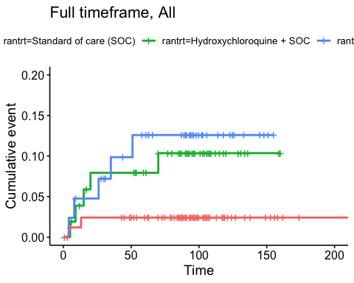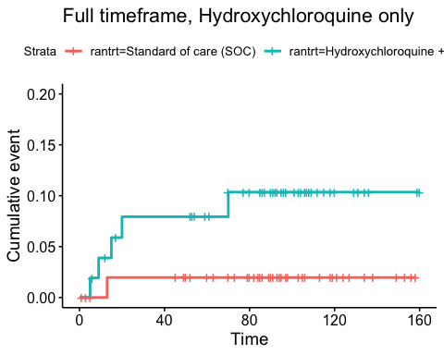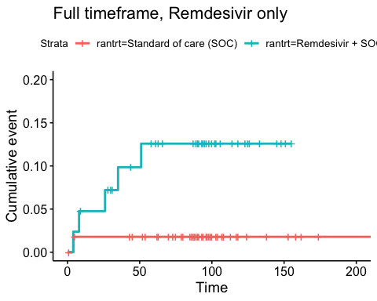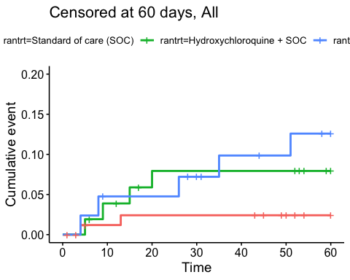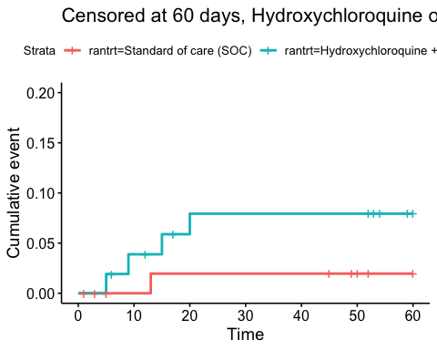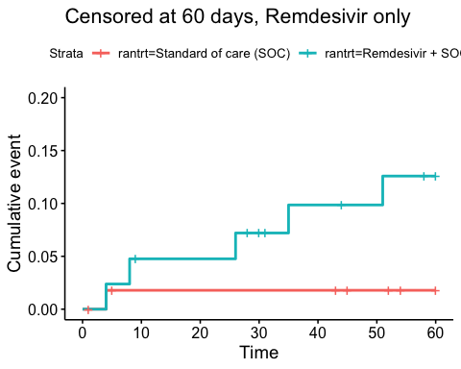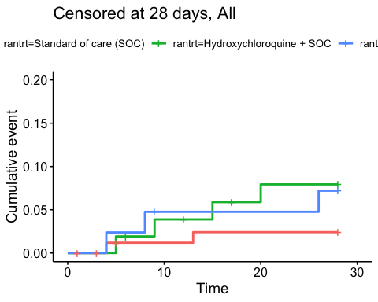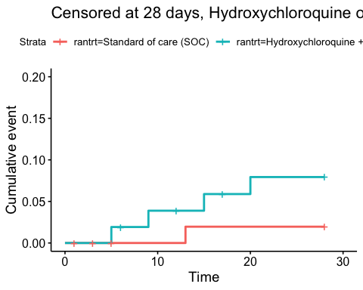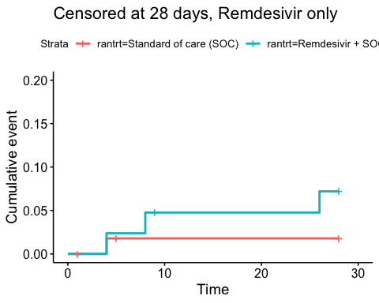

### Efficacy estimates

Relative risk estimates and p-values

|  |  |  |
| --- | --- | --- |
| Timeframe, Population | Relative risk | P-value |
| Full timeframe, All | Not applicable | 0.082 |
| Full timeframe, Hydroxychloroquine only | 4 (95% CI 0.81 to 19.82) | 0.090 |
| Full timeframe, Remdesivir only | 5.53 (95% CI 1.09 to 28.11) | 0.039 |
| Censored at 60 days, All | Not applicable | 0.100 |
| Censored at 60 days, Hydroxychloroquine only | 3.46 (95% CI 0.6 to 19.99) | 0.165 |
| Censored at 60 days, Remdesivir only | 5.53 (95% CI 1.09 to 28.11) | 0.039 |
| Censored at 28 days, All | Not applicable | 0.306 |
| Censored at 28 days, Hydroxychloroquine only | 3.46 (95% CI 0.6 to 19.99) | 0.165 |
| Censored at 28 days, Remdesivir only | 3.73 (95% CI 0.51 to 27.14) | 0.194 |

## Viral load

### Plots

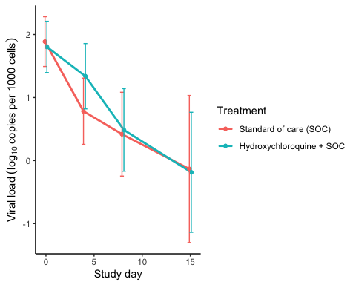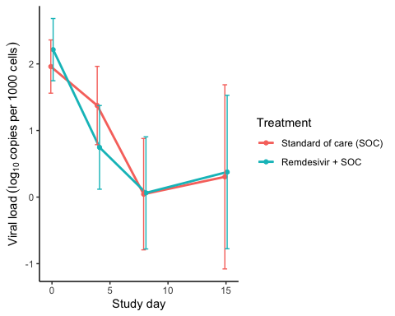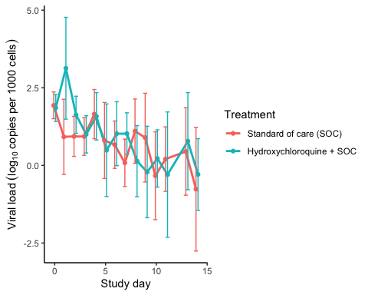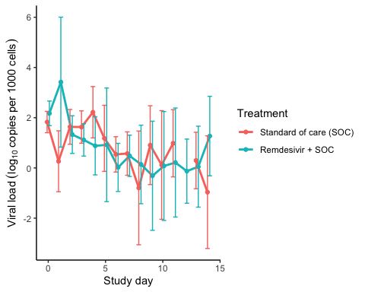

### Marginal probability estimates by treatment group and difference

Estimated treatment effect, Hydroxychloroquine

|  |  |  |  |  |  |
| --- | --- | --- | --- | --- | --- |
| Treatment | Explanation | Estimate | Lower 95% CL | Upper 95% CL | P-value |
| Standard of care (SOC) | Slope 1st week | -0.212 | -0.287 | -0.138 | 0.000 |
| Hydroxychloroquine + SOC | Slope 1st week | -0.135 | -0.212 | -0.059 | 0.001 |
| Hydroxychloroquine + SOC | Difference in slope | 0.077 | -0.030 | 0.184 | 0.159 |
| Standard of care (SOC) | Level at day 10 | 0.280 | -0.143 | 0.703 | 0.195 |
| Hydroxychloroquine + SOC | Level at day 10 | 0.507 | 0.120 | 0.894 | 0.010 |
| Hydroxychloroquine + SOC | Difference at day 10 | 0.227 | -0.347 | 0.800 | 0.438 |

Estimated treatment effect, Remdesivir

|  |  |  |  |  |  |
| --- | --- | --- | --- | --- | --- |
| Treatment | Explanation | Estimate | Lower 95% CL | Upper 95% CL | P-value |
| Standard of care (SOC) | Slope 1st week | -0.214 | -0.300 | -0.128 | 0.000 |
| Remdesivir + SOC | Slope 1st week | -0.291 | -0.388 | -0.194 | 0.000 |
| Remdesivir + SOC | Difference in slope | -0.077 | -0.206 | 0.053 | 0.244 |
| Standard of care (SOC) | Level at day 10 | 0.774 | 0.349 | 1.198 | 0.000 |
| Remdesivir + SOC | Level at day 10 | 0.227 | -0.180 | 0.635 | 0.274 |
| Remdesivir + SOC | Difference at day 10 | -0.546 | -1.134 | 0.042 | 0.069 |

## Viral load subgroup analyses

### Plots, Hydroxychloroquine

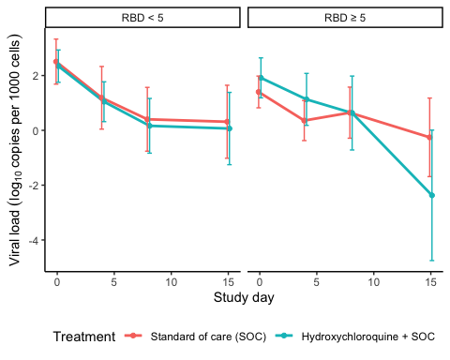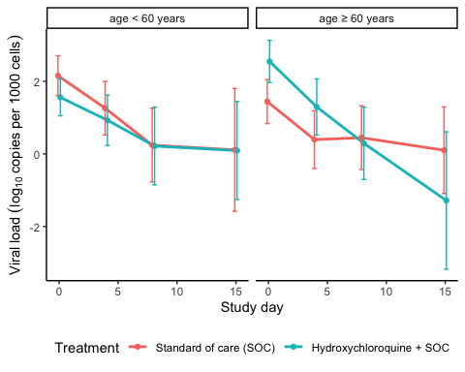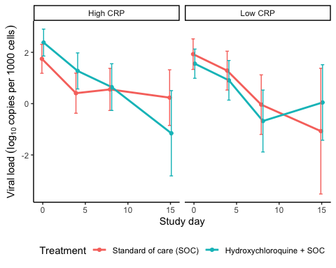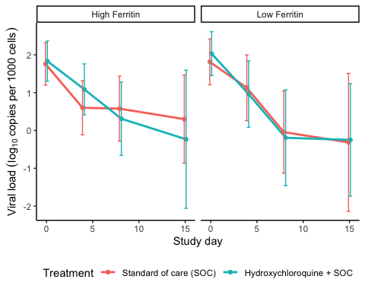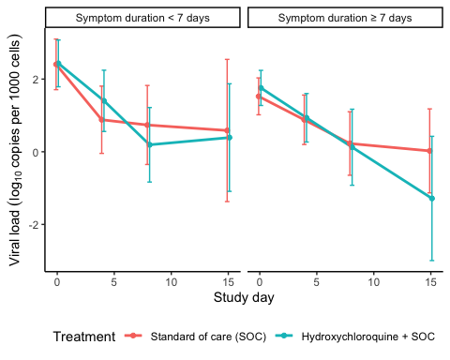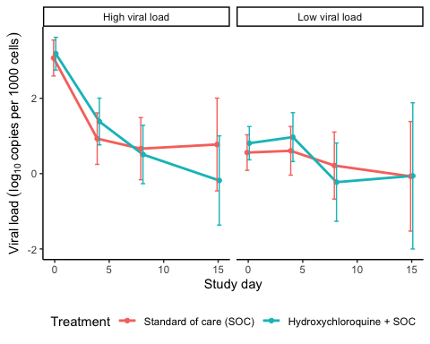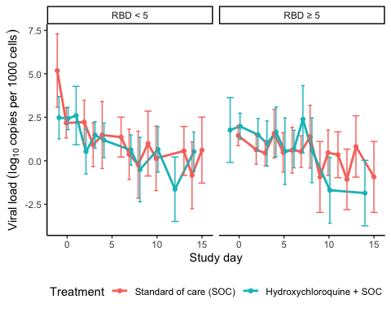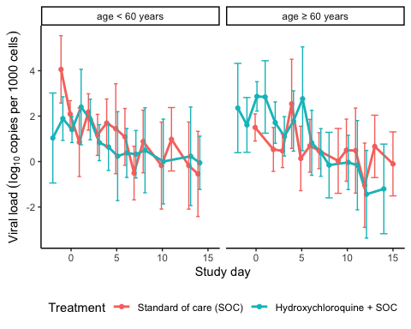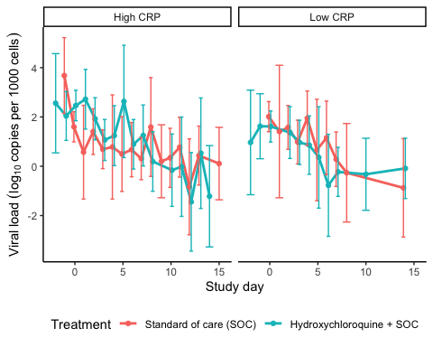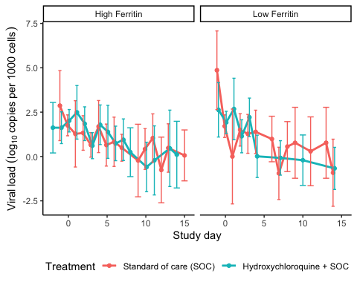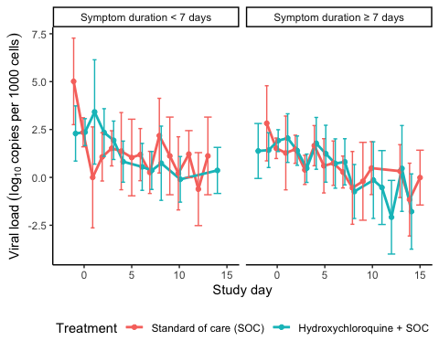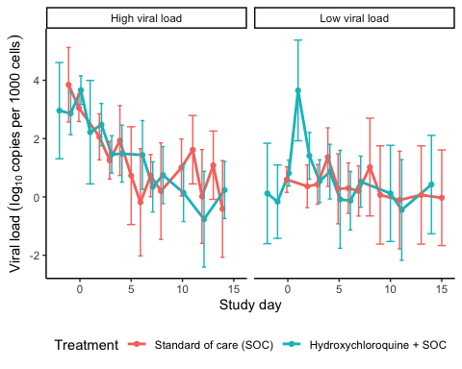

### Marginal probability estimates by treatment group and difference Hydroxychloroquine

Estimated treatment effect, Hydroxychloroquine

|  |  |  |  |  |  |  |
| --- | --- | --- | --- | --- | --- | --- |
| Treatment | Subgroup | Explanation | Estimate | Lower 95% CL | Upper 95% CL | P-value |
| Standard of care (SOC) | RBD < 5 | Slope 1st week by treatment and subgroup | -0.285 | -0.423 | -0.146 | 0.000 |
| Standard of care (SOC) | RBD ≥ 5 | Slope 1st week by treatment and subgroup | -0.139 | -0.246 | -0.032 | 0.011 |
| Hydroxychloroquine + SOC | RBD < 5 | Slope 1st week by treatment and subgroup | -0.293 | -0.406 | -0.179 | 0.000 |
| Hydroxychloroquine + SOC | RBD ≥ 5 | Slope 1st week by treatment and subgroup | -0.161 | -0.306 | -0.017 | 0.029 |
| Hydroxychloroquine + SOC | RBD < 5 | Treatment effect (Difference in slope) | -0.008 | -0.187 | 0.171 | 0.931 |
| Hydroxychloroquine + SOC | RBD ≥ 5 | Treatment effect (Difference in slope) | -0.022 | -0.202 | 0.158 | 0.809 |
| Hydroxychloroquine + SOC | RBD ≥ 5 | Treatment/Subgroup interaction | -0.014 | -0.268 | 0.239 | 0.912 |

Estimated treatment effect, Hydroxychloroquine

|  |  |  |  |  |  |  |
| --- | --- | --- | --- | --- | --- | --- |
| Treatment | Subgroup | Explanation | Estimate | Lower 95% CL | Upper 95% CL | P-value |
| Standard of care (SOC) | age < 60 years | Slope 1st week by treatment and subgroup | -0.253 | -0.374 | -0.132 | 0.000 |
| Standard of care (SOC) | age ≥ 60 years | Slope 1st week by treatment and subgroup | -0.149 | -0.255 | -0.043 | 0.006 |
| Hydroxychloroquine + SOC | age < 60 years | Slope 1st week by treatment and subgroup | -0.167 | -0.279 | -0.055 | 0.003 |
| Hydroxychloroquine + SOC | age ≥ 60 years | Slope 1st week by treatment and subgroup | -0.295 | -0.411 | -0.179 | 0.000 |
| Hydroxychloroquine + SOC | age < 60 years | Treatment effect (Difference in slope) | 0.086 | -0.079 | 0.251 | 0.308 |
| Hydroxychloroquine + SOC | age ≥ 60 years | Treatment effect (Difference in slope) | -0.146 | -0.303 | 0.011 | 0.068 |
| Hydroxychloroquine + SOC | age ≥ 60 years | Treatment/Subgroup interaction | -0.232 | -0.459 | -0.004 | 0.046 |

Estimated treatment effect, Hydroxychloroquine

|  |  |  |  |  |  |  |
| --- | --- | --- | --- | --- | --- | --- |
| Treatment | Subgroup | Explanation | Estimate | Lower 95% CL | Upper 95% CL | P-value |
| Standard of care (SOC) | High CRP | Slope 1st week by treatment and subgroup | -0.190 | -0.292 | -0.088 | 0.000 |
| Standard of care (SOC) | Low CRP | Slope 1st week by treatment and subgroup | -0.217 | -0.348 | -0.085 | 0.001 |
| Hydroxychloroquine + SOC | High CRP | Slope 1st week by treatment and subgroup | -0.232 | -0.340 | -0.123 | 0.000 |
| Hydroxychloroquine + SOC | Low CRP | Slope 1st week by treatment and subgroup | -0.237 | -0.359 | -0.115 | 0.000 |
| Hydroxychloroquine + SOC | High CRP | Treatment effect (Difference in slope) | -0.042 | -0.190 | 0.107 | 0.584 |
| Hydroxychloroquine + SOC | Low CRP | Treatment effect (Difference in slope) | -0.020 | -0.200 | 0.159 | 0.823 |
| Hydroxychloroquine + SOC | Low CRP | Treatment/Subgroup interaction | 0.021 | -0.212 | 0.254 | 0.859 |

Estimated treatment effect, Hydroxychloroquine

|  |  |  |  |  |  |  |
| --- | --- | --- | --- | --- | --- | --- |
| Treatment | Subgroup | Explanation | Estimate | Lower 95% CL | Upper 95% CL | P-value |
| Standard of care (SOC) | High Ferritin | Slope 1st week by treatment and subgroup | -0.179 | -0.281 | -0.077 | 0.001 |
| Standard of care (SOC) | Low Ferritin | Slope 1st week by treatment and subgroup | -0.235 | -0.370 | -0.101 | 0.001 |
| Hydroxychloroquine + SOC | High Ferritin | Slope 1st week by treatment and subgroup | -0.188 | -0.293 | -0.083 | 0.000 |
| Hydroxychloroquine + SOC | Low Ferritin | Slope 1st week by treatment and subgroup | -0.279 | -0.417 | -0.141 | 0.000 |
| Hydroxychloroquine + SOC | High Ferritin | Treatment effect (Difference in slope) | -0.009 | -0.155 | 0.138 | 0.909 |
| Hydroxychloroquine + SOC | Low Ferritin | Treatment effect (Difference in slope) | -0.044 | -0.237 | 0.149 | 0.658 |
| Hydroxychloroquine + SOC | Low Ferritin | Treatment/Subgroup interaction | -0.035 | -0.277 | 0.207 | 0.777 |

Estimated treatment effect, Hydroxychloroquine

|  |  |  |  |  |  |  |
| --- | --- | --- | --- | --- | --- | --- |
| Treatment | Subgroup | Explanation | Estimate | Lower 95% CL | Upper 95% CL | P-value |
| Standard of care (SOC) | Symptom duration < 7 days | Slope 1st week by treatment and subgroup | -0.263 | -0.392 | -0.135 | 0.000 |
| Standard of care (SOC) | Symptom duration ≥ 7 days | Slope 1st week by treatment and subgroup | -0.164 | -0.269 | -0.059 | 0.002 |
| Hydroxychloroquine + SOC | Symptom duration < 7 days | Slope 1st week by treatment and subgroup | -0.283 | -0.403 | -0.162 | 0.000 |
| Hydroxychloroquine + SOC | Symptom duration ≥ 7 days | Slope 1st week by treatment and subgroup | -0.202 | -0.312 | -0.092 | 0.000 |
| Hydroxychloroquine + SOC | Symptom duration < 7 days | Treatment effect (Difference in slope) | -0.019 | -0.195 | 0.157 | 0.830 |
| Hydroxychloroquine + SOC | Symptom duration ≥ 7 days | Treatment effect (Difference in slope) | -0.038 | -0.190 | 0.115 | 0.628 |
| Hydroxychloroquine + SOC | Symptom duration ≥ 7 days | Treatment/Subgroup interaction | -0.018 | -0.251 | 0.214 | 0.877 |

Estimated treatment effect, Hydroxychloroquine

|  |  |  |  |  |  |  |
| --- | --- | --- | --- | --- | --- | --- |
| Treatment | Subgroup | Explanation | Estimate | Lower 95% CL | Upper 95% CL | P-value |
| Standard of care (SOC) | High viral load | Slope 1st week by treatment and subgroup | -0.370 | -0.474 | -0.266 | 0.000 |
| Standard of care (SOC) | Low viral load | Slope 1st week by treatment and subgroup | -0.030 | -0.135 | 0.075 | 0.575 |
| Hydroxychloroquine + SOC | High viral load | Slope 1st week by treatment and subgroup | -0.384 | -0.483 | -0.286 | 0.000 |
| Hydroxychloroquine + SOC | Low viral load | Slope 1st week by treatment and subgroup | -0.063 | -0.171 | 0.044 | 0.248 |
| Hydroxychloroquine + SOC | High viral load | Treatment effect (Difference in slope) | -0.014 | -0.157 | 0.129 | 0.848 |
| Hydroxychloroquine + SOC | Low viral load | Treatment effect (Difference in slope) | -0.033 | -0.183 | 0.117 | 0.664 |
| Hydroxychloroquine + SOC | Low viral load | Treatment/Subgroup interaction | -0.019 | -0.227 | 0.188 | 0.855 |

### Plots Remdesivir

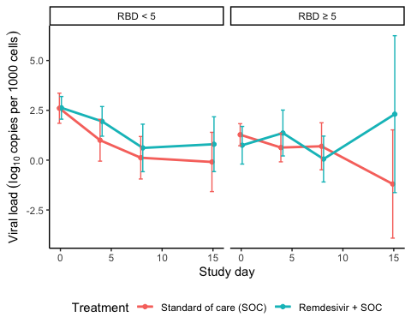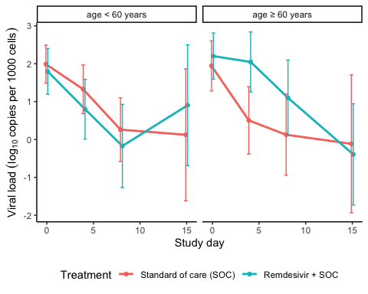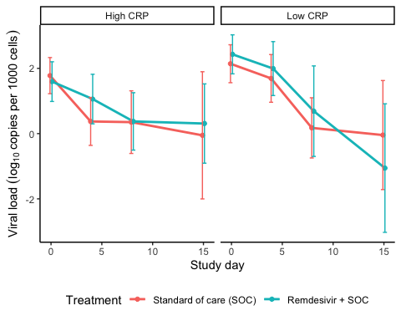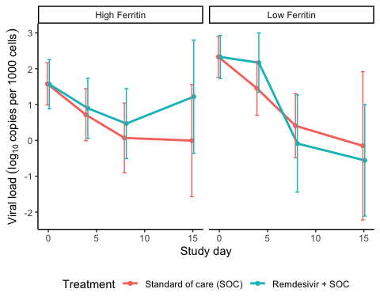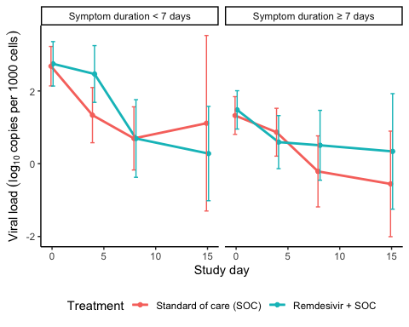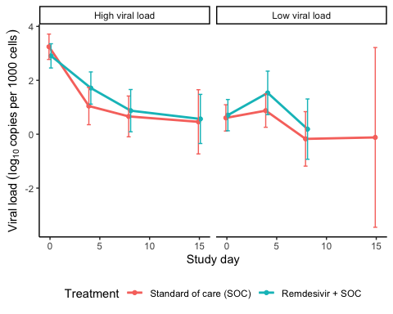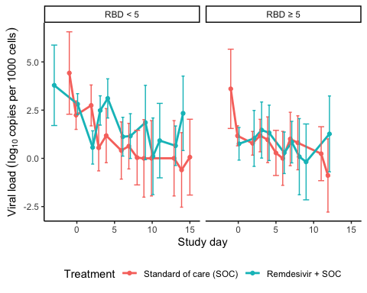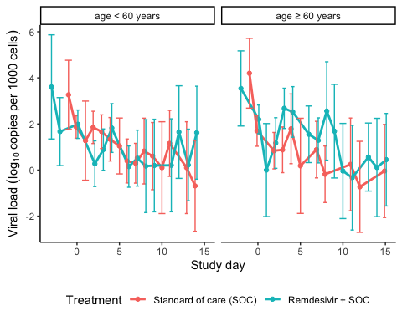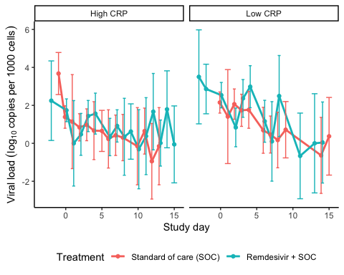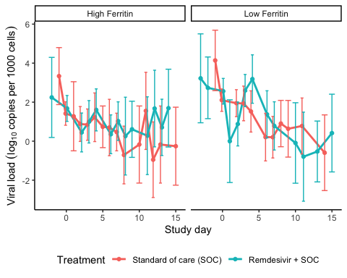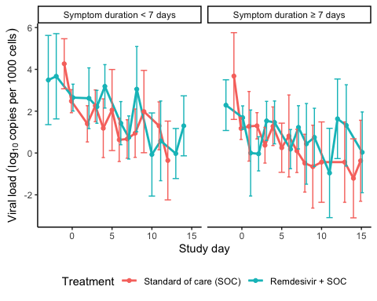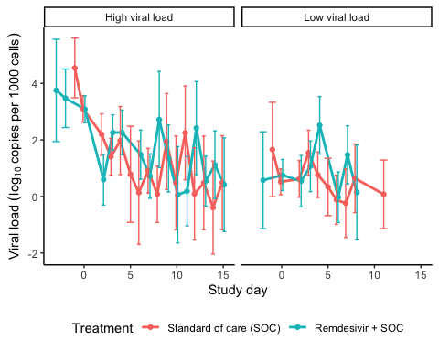

### Marginal probability estimates by treatment group and difference Remdesivir

Estimated treatment effect, Remdesivir

|  |  |  |  |  |  |  |
| --- | --- | --- | --- | --- | --- | --- |
| Treatment | Subgroup | Explanation | Estimate | Lower 95% CL | Upper 95% CL | P-value |
| Standard of care (SOC) | RBD < 5 | Slope 1st week by treatment and subgroup | -0.338 | -0.490 | -0.185 | 0.000 |
| Standard of care (SOC) | RBD ≥ 5 | Slope 1st week by treatment and subgroup | -0.105 | -0.237 | 0.028 | 0.123 |
| Remdesivir + SOC | RBD < 5 | Slope 1st week by treatment and subgroup | -0.225 | -0.353 | -0.096 | 0.001 |
| Remdesivir + SOC | RBD ≥ 5 | Slope 1st week by treatment and subgroup | -0.047 | -0.200 | 0.105 | 0.543 |
| Remdesivir + SOC | RBD < 5 | Treatment effect (Difference in slope) | 0.113 | -0.087 | 0.313 | 0.267 |
| Remdesivir + SOC | RBD ≥ 5 | Treatment effect (Difference in slope) | 0.057 | -0.145 | 0.259 | 0.579 |
| Remdesivir + SOC | RBD ≥ 5 | Treatment/Subgroup interaction | -0.056 | -0.340 | 0.228 | 0.700 |

Estimated treatment effect, Remdesivir

|  |  |  |  |  |  |  |
| --- | --- | --- | --- | --- | --- | --- |
| Treatment | Subgroup | Explanation | Estimate | Lower 95% CL | Upper 95% CL | P-value |
| Standard of care (SOC) | age < 60 years | Slope 1st week by treatment and subgroup | -0.216 | -0.316 | -0.116 | 0.000 |
| Standard of care (SOC) | age ≥ 60 years | Slope 1st week by treatment and subgroup | -0.258 | -0.401 | -0.115 | 0.000 |
| Remdesivir + SOC | age < 60 years | Slope 1st week by treatment and subgroup | -0.253 | -0.373 | -0.132 | 0.000 |
| Remdesivir + SOC | age ≥ 60 years | Slope 1st week by treatment and subgroup | -0.108 | -0.223 | 0.007 | 0.066 |
| Remdesivir + SOC | age < 60 years | Treatment effect (Difference in slope) | -0.037 | -0.194 | 0.120 | 0.645 |
| Remdesivir + SOC | age ≥ 60 years | Treatment effect (Difference in slope) | 0.150 | -0.033 | 0.334 | 0.108 |
| Remdesivir + SOC | age ≥ 60 years | Treatment/Subgroup interaction | 0.187 | -0.054 | 0.429 | 0.128 |

Estimated treatment effect, Remdesivir

|  |  |  |  |  |  |  |
| --- | --- | --- | --- | --- | --- | --- |
| Treatment | Subgroup | Explanation | Estimate | Lower 95% CL | Upper 95% CL | P-value |
| Standard of care (SOC) | High CRP | Slope 1st week by treatment and subgroup | -0.234 | -0.347 | -0.122 | 0.000 |
| Standard of care (SOC) | Low CRP | Slope 1st week by treatment and subgroup | -0.227 | -0.351 | -0.104 | 0.000 |
| Remdesivir + SOC | High CRP | Slope 1st week by treatment and subgroup | -0.149 | -0.256 | -0.042 | 0.007 |
| Remdesivir + SOC | Low CRP | Slope 1st week by treatment and subgroup | -0.172 | -0.310 | -0.034 | 0.015 |
| Remdesivir + SOC | High CRP | Treatment effect (Difference in slope) | 0.085 | -0.070 | 0.241 | 0.283 |
| Remdesivir + SOC | Low CRP | Treatment effect (Difference in slope) | 0.056 | -0.130 | 0.241 | 0.557 |
| Remdesivir + SOC | Low CRP | Treatment/Subgroup interaction | -0.030 | -0.272 | 0.212 | 0.811 |

Estimated treatment effect, Remdesivir

|  |  |  |  |  |  |  |
| --- | --- | --- | --- | --- | --- | --- |
| Treatment | Subgroup | Explanation | Estimate | Lower 95% CL | Upper 95% CL | P-value |
| Standard of care (SOC) | High Ferritin | Slope 1st week by treatment and subgroup | -0.193 | -0.306 | -0.080 | 0.001 |
| Standard of care (SOC) | Low Ferritin | Slope 1st week by treatment and subgroup | -0.257 | -0.379 | -0.135 | 0.000 |
| Remdesivir + SOC | High Ferritin | Slope 1st week by treatment and subgroup | -0.147 | -0.266 | -0.027 | 0.017 |
| Remdesivir + SOC | Low Ferritin | Slope 1st week by treatment and subgroup | -0.188 | -0.319 | -0.056 | 0.005 |
| Remdesivir + SOC | High Ferritin | Treatment effect (Difference in slope) | 0.047 | -0.118 | 0.211 | 0.580 |
| Remdesivir + SOC | Low Ferritin | Treatment effect (Difference in slope) | 0.069 | -0.110 | 0.248 | 0.448 |
| Remdesivir + SOC | Low Ferritin | Treatment/Subgroup interaction | 0.023 | -0.221 | 0.266 | 0.854 |

Estimated treatment effect, Remdesivir

|  |  |  |  |  |  |  |
| --- | --- | --- | --- | --- | --- | --- |
| Treatment | Subgroup | Explanation | Estimate | Lower 95% CL | Upper 95% CL | P-value |
| Standard of care (SOC) | Symptom duration < 7 days | Slope 1st week by treatment and subgroup | -0.286 | -0.396 | -0.175 | 0.000 |
| Standard of care (SOC) | Symptom duration ≥ 7 days | Slope 1st week by treatment and subgroup | -0.169 | -0.294 | -0.044 | 0.008 |
| Remdesivir + SOC | Symptom duration < 7 days | Slope 1st week by treatment and subgroup | -0.202 | -0.324 | -0.081 | 0.001 |
| Remdesivir + SOC | Symptom duration ≥ 7 days | Slope 1st week by treatment and subgroup | -0.154 | -0.268 | -0.040 | 0.008 |
| Remdesivir + SOC | Symptom duration < 7 days | Treatment effect (Difference in slope) | 0.083 | -0.081 | 0.247 | 0.322 |
| Remdesivir + SOC | Symptom duration ≥ 7 days | Treatment effect (Difference in slope) | 0.015 | -0.154 | 0.184 | 0.861 |
| Remdesivir + SOC | Symptom duration ≥ 7 days | Treatment/Subgroup interaction | -0.068 | -0.304 | 0.168 | 0.572 |

Estimated treatment effect, Remdesivir

|  |  |  |  |  |  |  |
| --- | --- | --- | --- | --- | --- | --- |
| Treatment | Subgroup | Explanation | Estimate | Lower 95% CL | Upper 95% CL | P-value |
| Standard of care (SOC) | High viral load | Slope 1st week by treatment and subgroup | -0.386 | -0.490 | -0.282 | 0.000 |
| Standard of care (SOC) | Low viral load | Slope 1st week by treatment and subgroup | -0.043 | -0.159 | 0.073 | 0.467 |
| Remdesivir + SOC | High viral load | Slope 1st week by treatment and subgroup | -0.280 | -0.376 | -0.185 | 0.000 |
| Remdesivir + SOC | Low viral load | Slope 1st week by treatment and subgroup | 0.035 | -0.095 | 0.166 | 0.593 |
| Remdesivir + SOC | High viral load | Treatment effect (Difference in slope) | 0.106 | -0.035 | 0.247 | 0.142 |
| Remdesivir + SOC | Low viral load | Treatment effect (Difference in slope) | 0.079 | -0.096 | 0.253 | 0.377 |
| Remdesivir + SOC | Low viral load | Treatment/Subgroup interaction | -0.027 | -0.252 | 0.197 | 0.812 |

## Respiratory failure by pO2/FiO2-ratio

### Plots

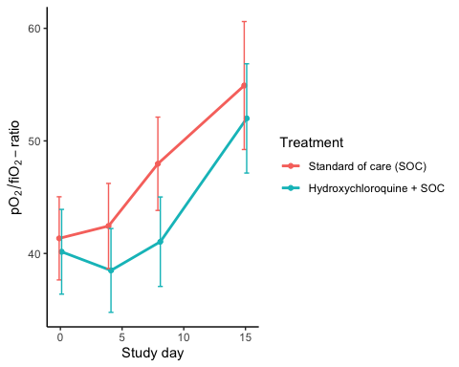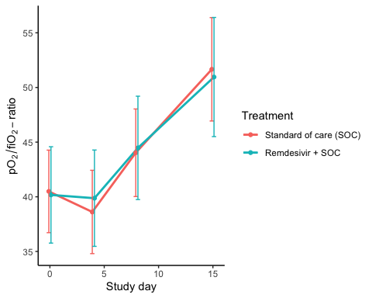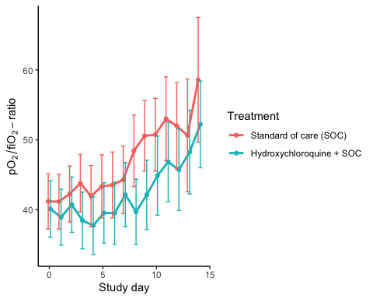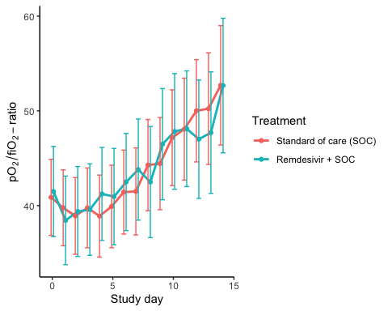

### Marginal probability estimates by treatment group and difference

Estimated treatment effect, Hydroxychloroquine

|  |  |  |  |  |  |
| --- | --- | --- | --- | --- | --- |
| Treatment | Explanation | Estimate | Lower 95% CL | Upper 95% CL | P-value |
| Standard of care (SOC) | Slope 1st week | 1.174 | 0.488 | 1.860 | 0.001 |
| Hydroxychloroquine + SOC | Slope 1st week | 0.356 | -0.291 | 1.004 | 0.281 |
| Hydroxychloroquine + SOC | Difference in slope | -0.818 | -1.762 | 0.126 | 0.089 |
| Standard of care (SOC) | Level at day 10 | 56.915 | 49.883 | 63.948 | 0.000 |
| Hydroxychloroquine + SOC | Level at day 10 | 53.614 | 46.819 | 60.410 | 0.000 |
| Hydroxychloroquine + SOC | Difference at day 10 | -3.301 | -13.080 | 6.478 | 0.508 |

Estimated treatment effect, Remdesivir

|  |  |  |  |  |  |
| --- | --- | --- | --- | --- | --- |
| Treatment | Explanation | Estimate | Lower 95% CL | Upper 95% CL | P-value |
| Standard of care (SOC) | Slope 1st week | 0.471 | -0.023 | 0.964 | 0.062 |
| Remdesivir + SOC | Slope 1st week | 0.549 | -0.033 | 1.131 | 0.065 |
| Remdesivir + SOC | Difference in slope | 0.078 | -0.685 | 0.841 | 0.841 |
| Standard of care (SOC) | Level at day 10 | 49.779 | 44.693 | 54.865 | 0.000 |
| Remdesivir + SOC | Level at day 10 | 48.355 | 42.338 | 54.372 | 0.000 |
| Remdesivir + SOC | Difference at day 10 | -1.424 | -9.302 | 6.455 | 0.723 |

## Dichotomous endpoints

### Descriptives

Hydroxycholoquine

|  |  |  |
| --- | --- | --- |
| Outcome | Standard of care (SOC) | Hydroxychloroquine + SOC |
| Mortality during hospitalisation | 1 (1.9%) | 5 (9.6%) |
| Mortality (censored at day 28) | 1 (1.9%) | 5 (9.6%) |
| Mortality (censored at day 60) | 1 (1.9%) | 5 (9.6%) |
| WHO disease state progression | 4 (7.4%) | 13 (25%) |
| WHO disease state progression (censoreda at day 28) | 4 (7.4%) | 13 (25%) |
| WHO disease state progression (censoreda at day 60) | 4 (7.4%) | 13 (25%) |
| Mechanical ventilation during hospitalisation | 2 (3.7%) | 6 (11.5%) |
| Mechanical ventilation (censored at day 28) | 2 (3.7%) | 6 (11.5%) |
| Mechanical ventilation (censored at day 60) | 2 (3.7%) | 6 (11.5%) |
| Admission to ICU during hospitalisation | 6 (11.1%) | 13 (25%) |
| Admission to ICU (censored at day 28) | 6 (11.1%) | 13 (25%) |
| Admission to ICU (censored at day 60) | 6 (11.1%) | 13 (25%) |

Figures are number of patients with the outcome and percent (%)

Remdesivir

|  |  |  |
| --- | --- | --- |
| Outcome | Standard of care (SOC) | Remdesivir + SOC |
| Mortality during hospitalisation | 3 (5.3%) | 3 (7.1%) |
| Mortality (censored at day 28) | 2 (3.5%) | 1 (2.4%) |
| Mortality (censored at day 60) | 3 (5.3%) | 2 (4.8%) |
| WHO disease state progression | 8 (14%) | 7 (16.7%) |
| WHO disease state progression (censoreda at day 28) | 8 (14%) | 7 (16.7%) |
| WHO disease state progression (censoreda at day 60) | 8 (14%) | 7 (16.7%) |
| Mechanical ventilation during hospitalisation | 5 (8.8%) | 8 (19%) |
| Mechanical ventilation (censored at day 28) | 5 (8.8%) | 8 (19%) |
| Mechanical ventilation (censored at day 60) | 5 (8.8%) | 8 (19%) |
| Admission to ICU during hospitalisation | 9 (15.8%) | 10 (23.8%) |
| Admission to ICU (censored at day 28) | 9 (15.8%) | 10 (23.8%) |
| Admission to ICU (censored at day 60) | 9 (15.8%) | 10 (23.8%) |

Figures are number of patients with the outcome and percent (%)

### Marginal probability estimates by treatment group and difference

Hydroxychloroquine

|  |  |  |  |
| --- | --- | --- | --- |
| Outcome | Standard of care (SOC) | Hydroxychloroquine + SOC | Estimated marginal treatment effect |
| Mortality during hospitalisation | 1.9% (-1.7 to 5.4) | 9.6% (1.6 to 17.6) | 7.8% (-1 to 16.5) |
| Mortality (censored at day 28) | 1.9% (-1.7 to 5.4) | 9.6% (1.6 to 17.6) | 7.8% (-1 to 16.5) |
| Mortality (censored at day 60) | 1.9% (-1.7 to 5.4) | 9.6% (1.6 to 17.6) | 7.8% (-1 to 16.5) |
| WHO disease state progression | 7.4% (0.4 to 14.4) | 25% (13.2 to 36.8) | 17.6% (3.9 to 31.3) |
| WHO disease state progression (censoreda at day 28) | 7.4% (0.4 to 14.4) | 25% (13.2 to 36.8) | 17.6% (3.9 to 31.3) |
| WHO disease state progression (censoreda at day 60) | 7.4% (0.4 to 14.4) | 25% (13.2 to 36.8) | 17.6% (3.9 to 31.3) |
| Mechanical ventilation during hospitalisation | 3.7% (-1.3 to 8.7) | 11.5% (2.9 to 20.2) | 7.8% (-2.2 to 17.9) |
| Mechanical ventilation (censored at day 28) | 3.7% (-1.3 to 8.7) | 11.5% (2.9 to 20.2) | 7.8% (-2.2 to 17.9) |
| Mechanical ventilation (censored at day 60) | 3.7% (-1.3 to 8.7) | 11.5% (2.9 to 20.2) | 7.8% (-2.2 to 17.9) |
| Admission to ICU during hospitalisation | 11.1% (2.7 to 19.5) | 25% (13.2 to 36.8) | 13.9% (-0.6 to 28.3) |
| Admission to ICU (censored at day 28) | 11.1% (2.7 to 19.5) | 25% (13.2 to 36.8) | 13.9% (-0.6 to 28.3) |
| Admission to ICU (censored at day 60) | 11.1% (2.7 to 19.5) | 25% (13.2 to 36.8) | 13.9% (-0.6 to 28.3) |

Remdesivir

|  |  |  |  |
| --- | --- | --- | --- |
| Outcome | Standard of care (SOC) | Remdesivir + SOC | Estimated marginal treatment effect |
| Mortality during hospitalisation | 5.3% (-0.5 to 11.1) | 7.1% (-0.6 to 14.9) | 1.9% (-7.8 to 11.6) |
| Mortality (censored at day 28) | 3.5% (-1.3 to 8.3) | 2.4% (-2.2 to 7) | -1.1% (-7.8 to 5.5) |
| Mortality (censored at day 60) | 5.3% (-0.5 to 11.1) | 4.8% (-1.7 to 11.2) | -0.5% (-9.2 to 8.2) |
| WHO disease state progression | 14% (5 to 23.1) | 16.7% (5.4 to 27.9) | 2.6% (-11.8 to 17.1) |
| WHO disease state progression (censoreda at day 28) | 14% (5 to 23.1) | 16.7% (5.4 to 27.9) | 2.6% (-11.8 to 17.1) |
| WHO disease state progression (censoreda at day 60) | 14% (5 to 23.1) | 16.7% (5.4 to 27.9) | 2.6% (-11.8 to 17.1) |
| Mechanical ventilation during hospitalisation | 8.8% (1.4 to 16.1) | 19% (7.2 to 30.9) | 10.3% (-3.7 to 24.2) |
| Mechanical ventilation (censored at day 28) | 8.8% (1.4 to 16.1) | 19% (7.2 to 30.9) | 10.3% (-3.7 to 24.2) |
| Mechanical ventilation (censored at day 60) | 8.8% (1.4 to 16.1) | 19% (7.2 to 30.9) | 10.3% (-3.7 to 24.2) |
| Admission to ICU during hospitalisation | 15.8% (6.3 to 25.3) | 23.8% (10.9 to 36.7) | 8% (-8 to 24) |
| Admission to ICU (censored at day 28) | 15.8% (6.3 to 25.3) | 23.8% (10.9 to 36.7) | 8% (-8 to 24) |
| Admission to ICU (censored at day 60) | 15.8% (6.3 to 25.3) | 23.8% (10.9 to 36.7) | 8% (-8 to 24) |

## Inflammatory laboratory parameters

### Descriptives

CRP (mg/L), HCQ

|  |  |  |  |
| --- | --- | --- | --- |
| Days since randomisation | Statistic | Standard of care (SOC) | Hydroxychloroquine + SOC |
| 0 days | Mean (SD) | 81.74 (66.4) | 94.6 (71.76) |
| 0 days | Median [IQR] | 60.5 [38.5 - 108] | 73 [33 - 151.25] |
| 0 days | Missing / Non-Missing | 0 / 54 | 0 / 52 |
| 1 days | Mean (SD) | 93.69 (78.3) | 86.41 (67.44) |
| 1 days | Median [IQR] | 66 [47 - 107] | 69.5 [40.25 - 129] |
| 1 days | Missing / Non-Missing | 10 / 43 | 8 / 44 |
| 2 days | Mean (SD) | 94.15 (76.35) | 81.28 (77.07) |
| 2 days | Median [IQR] | 73 [42.75 - 120.25] | 67 [28 - 113] |
| 2 days | Missing / Non-Missing | 10 / 40 | 4 / 49 |
| 3 days | Mean (SD) | 90.28 (73.25) | 78.52 (76.43) |
| 3 days | Median [IQR] | 70 [36.75 - 121.75] | 61 [20.75 - 104.5] |
| 3 days | Missing / Non-Missing | 10 / 34 | 5 / 42 |
| 4 days | Mean (SD) | 103.22 (91.19) | 78.38 (72.07) |
| 4 days | Median [IQR] | 77 [41 - 122] | 70 [20.5 - 97] |
| 4 days | Missing / Non-Missing | 5 / 29 | 6 / 35 |
| 5 days | Mean (SD) | 92.19 (90.71) | 74.43 (60.02) |
| 5 days | Median [IQR] | 57.5 [34.75 - 92.75] | 67 [22 - 98] |
| 5 days | Missing / Non-Missing | 2 / 28 | 3 / 33 |
| 6 days | Mean (SD) | 81.48 (81.6) | 72.89 (72.12) |
| 6 days | Median [IQR] | 49 [37.75 - 95.5] | 43 [19.75 - 105.5] |
| 6 days | Missing / Non-Missing | 3 / 24 | 4 / 26 |
| 7 days | Mean (SD) | 68.53 (67.53) | 89.53 (88.02) |
| 7 days | Median [IQR] | 37 [22 - 107.25] | 55 [15.25 - 143.75] |
| 7 days | Missing / Non-Missing | 4 / 18 | 3 / 24 |
| 8 days | Mean (SD) | 51.87 (50.19) | 103.4 (106.9) |
| 8 days | Median [IQR] | 37 [15 - 78] | 66.5 [19.25 - 170.75] |
| 8 days | Missing / Non-Missing | 2 / 18 | 6 / 18 |
| 9 days | Mean (SD) | 48.78 (44.86) | 82.47 (97.76) |
| 9 days | Median [IQR] | 30 [12 - 84] | 36 [10.5 - 136.5] |
| 9 days | Missing / Non-Missing | 3 / 17 | 0 / 19 |
| 10 days | Mean (SD) | 34.43 (42.73) | 87.04 (101.14) |
| 10 days | Median [IQR] | 19 [7.03 - 31.5] | 44 [15 - 143] |
| 10 days | Missing / Non-Missing | 3 / 14 | 0 / 13 |
| 11 days | Mean (SD) | 42.67 (38.9) | 99.6 (135.55) |
| 11 days | Median [IQR] | 41 [11 - 52] | 51 [9.5 - 119] |
| 11 days | Missing / Non-Missing | 4 / 9 | 1 / 11 |
| 12 days | Mean (SD) | 87 (64.32) | 133.4 (209.25) |
| 12 days | Median [IQR] | 88 [49.5 - 106.25] | 44 [11 - 110] |
| 12 days | Missing / Non-Missing | 3 / 6 | 2 / 9 |
| 13 days | Mean (SD) | 114.4 (82.61) | 86.12 (119.82) |
| 13 days | Median [IQR] | 115 [46 - 144] | 35 [7 - 106] |
| 13 days | Missing / Non-Missing | 3 / 5 | 2 / 9 |
| 14 days | Mean (SD) | 64.53 (85.71) | 39.58 (52.11) |
| 14 days | Median [IQR] | 33 [22.03 - 75.5] | 20 [4.6 - 50] |
| 14 days | Missing / Non-Missing | 0 / 4 | 0 / 9 |

CRP (mg/L), Remdesivir

|  |  |  |  |
| --- | --- | --- | --- |
| Days since randomisation | Statistic | Standard of care (SOC) | Remdesivir + SOC |
| 0 days | Mean (SD) | 89.45 (67.05) | 99.73 (65.7) |
| 0 days | Median [IQR] | 79 [45 - 116] | 84 [45.25 - 160.25] |
| 0 days | Missing / Non-Missing | 0 / 57 | 2 / 40 |
| 1 days | Mean (SD) | 95.04 (70.1) | 108.25 (74.49) |
| 1 days | Median [IQR] | 84 [41.25 - 124] | 99 [59.75 - 153.5] |
| 1 days | Missing / Non-Missing | 11 / 46 | 6 / 36 |
| 2 days | Mean (SD) | 96.94 (64.29) | 87.53 (81.93) |
| 2 days | Median [IQR] | 92 [46.5 - 130.5] | 57.5 [29.75 - 109.5] |
| 2 days | Missing / Non-Missing | 6 / 47 | 3 / 38 |
| 3 days | Mean (SD) | 97.54 (59.65) | 85 (78.64) |
| 3 days | Median [IQR] | 85 [52 - 128.5] | 54.5 [25 - 133.5] |
| 3 days | Missing / Non-Missing | 9 / 39 | 4 / 32 |
| 4 days | Mean (SD) | 108.38 (86.75) | 80.6 (82.79) |
| 4 days | Median [IQR] | 99 [39.5 - 136] | 47 [20.25 - 108.25] |
| 4 days | Missing / Non-Missing | 5 / 35 | 5 / 28 |
| 5 days | Mean (SD) | 108.7 (96.47) | 73.31 (72.62) |
| 5 days | Median [IQR] | 90 [33.5 - 151] | 48 [17 - 112.75] |
| 5 days | Missing / Non-Missing | 8 / 30 | 7 / 22 |
| 6 days | Mean (SD) | 100.6 (91.07) | 68.23 (75.73) |
| 6 days | Median [IQR] | 73 [30.5 - 145] | 53 [9.23 - 69.5] |
| 6 days | Missing / Non-Missing | 6 / 31 | 4 / 22 |
| 7 days | Mean (SD) | 88.52 (76.26) | 71.62 (76.02) |
| 7 days | Median [IQR] | 67 [27.5 - 124.5] | 40.5 [11 - 131.25] |
| 7 days | Missing / Non-Missing | 4 / 26 | 0 / 22 |
| 8 days | Mean (SD) | 75.09 (69.79) | 89.2 (82.5) |
| 8 days | Median [IQR] | 43 [21 - 116.5] | 55 [28.5 - 140.5] |
| 8 days | Missing / Non-Missing | 0 / 27 | 2 / 15 |
| 9 days | Mean (SD) | 76.22 (74.03) | 78.91 (63) |
| 9 days | Median [IQR] | 40 [17.25 - 122.25] | 59 [29.5 - 110.5] |
| 9 days | Missing / Non-Missing | 4 / 20 | 4 / 11 |
| 10 days | Mean (SD) | 55.22 (63.13) | 58.83 (51.63) |
| 10 days | Median [IQR] | 26 [6.5 - 97.5] | 34 [17.5 - 99] |
| 10 days | Missing / Non-Missing | 6 / 14 | 2 / 12 |
| 11 days | Mean (SD) | 65.88 (43.57) | 70.27 (91.36) |
| 11 days | Median [IQR] | 55 [37 - 101] | 29 [13.5 - 90.5] |
| 11 days | Missing / Non-Missing | 4 / 13 | 3 / 11 |
| 12 days | Mean (SD) | 72.97 (59.47) | 55.07 (64.96) |
| 12 days | Median [IQR] | 72 [8 - 107] | 19 [12.25 - 90.75] |
| 12 days | Missing / Non-Missing | 3 / 13 | 3 / 10 |
| 13 days | Mean (SD) | 112.85 (87.65) | 62.2 (71.19) |
| 13 days | Median [IQR] | 99 [46 - 187] | 23 [14 - 92] |
| 13 days | Missing / Non-Missing | 2 / 13 | 2 / 9 |
| 14 days | Mean (SD) | 102.38 (105.72) | 54.83 (95.49) |
| 14 days | Median [IQR] | 35.5 [26.75 - 197.75] | 13.5 [7.85 - 43.75] |
| 14 days | Missing / Non-Missing | 2 / 8 | 0 / 8 |

Ferritin (µg/L), HCQ

|  |  |  |  |
| --- | --- | --- | --- |
| Days since randomisation | Statistic | Standard of care (SOC) | Hydroxychloroquine + SOC |
| 0 days | Mean (SD) | 589.16 (535.63) | 1034.12 (805.55) |
| 0 days | Median [IQR] | 417.5 [245.75 - 794] | 965 [410.75 - 1236] |
| 0 days | Missing / Non-Missing | 4 / 50 | 0 / 52 |
| 1 days | Mean (SD) | 607.23 (358.39) | 1146.69 (856.92) |
| 1 days | Median [IQR] | 512 [345.5 - 982.5] | 1014 [528.5 - 1482] |
| 1 days | Missing / Non-Missing | 22 / 31 | 17 / 35 |
| 2 days | Mean (SD) | 715.86 (486.42) | 968.72 (770.49) |
| 2 days | Median [IQR] | 591.5 [291.75 - 1026] | 754.5 [487.75 - 1346] |
| 2 days | Missing / Non-Missing | 14 / 36 | 7 / 46 |
| 3 days | Mean (SD) | 849 (624.94) | 1266.92 (1007.05) |
| 3 days | Median [IQR] | 724 [335.5 - 1049.5] | 1071 [551.75 - 1701.25] |
| 3 days | Missing / Non-Missing | 13 / 31 | 11 / 36 |
| 4 days | Mean (SD) | 1263.33 (943.67) | 1321.28 (1482.37) |
| 4 days | Median [IQR] | 904.5 [633 - 1832.5] | 870 [466 - 1393] |
| 4 days | Missing / Non-Missing | 10 / 24 | 12 / 29 |
| 5 days | Mean (SD) | 1077.42 (780.56) | 1188.56 (1151.14) |
| 5 days | Median [IQR] | 819.5 [517.25 - 1732] | 872 [605 - 1158] |
| 5 days | Missing / Non-Missing | 6 / 24 | 11 / 25 |
| 6 days | Mean (SD) | 1005.1 (670.36) | 1269.61 (1285.12) |
| 6 days | Median [IQR] | 810 [470 - 1596] | 847 [464 - 1509.5] |
| 6 days | Missing / Non-Missing | 6 / 21 | 7 / 23 |
| 7 days | Mean (SD) | 1129.43 (757.63) | 1088.55 (735.31) |
| 7 days | Median [IQR] | 1044.5 [464.75 - 1670.25] | 857 [487.25 - 1521.25] |
| 7 days | Missing / Non-Missing | 8 / 14 | 5 / 22 |
| 8 days | Mean (SD) | 859.25 (722.24) | 1112.43 (656.31) |
| 8 days | Median [IQR] | 672.5 [414.75 - 1060.5] | 1032.5 [610.25 - 1497.25] |
| 8 days | Missing / Non-Missing | 4 / 16 | 10 / 14 |
| 9 days | Mean (SD) | 805.25 (646.14) | 973.13 (673.54) |
| 9 days | Median [IQR] | 576.5 [505.75 - 864.25] | 883.5 [397.75 - 1670.25] |
| 9 days | Missing / Non-Missing | 4 / 16 | 3 / 16 |
| 10 days | Mean (SD) | 748.73 (428.12) | 1429.45 (805.18) |
| 10 days | Median [IQR] | 728 [612 - 877.5] | 1301 [996 - 1925] |
| 10 days | Missing / Non-Missing | 6 / 11 | 4 / 9 |
| 11 days | Mean (SD) | 532.45 (211.27) | 1542 (1102.01) |
| 11 days | Median [IQR] | 564 [422 - 666] | 1178.5 [756.5 - 2708.75] |
| 11 days | Missing / Non-Missing | 4 / 9 | 4 / 8 |
| 12 days | Mean (SD) | 739.33 (423.02) | 1559 (1157.33) |
| 12 days | Median [IQR] | 665 [618 - 703] | 1127.5 [809.25 - 2327.75] |
| 12 days | Missing / Non-Missing | 3 / 6 | 5 / 6 |
| 13 days | Mean (SD) | 614.75 (272.49) | 1097.38 (950.91) |
| 13 days | Median [IQR] | 683.5 [536 - 762.25] | 941.5 [353.75 - 1528.75] |
| 13 days | Missing / Non-Missing | 4 / 4 | 3 / 8 |
| 14 days | Mean (SD) | 623 (15.56) | 859.88 (617.84) |
| 14 days | Median [IQR] | 623 [617.5 - 628.5] | 912 [346.25 - 1286.25] |
| 14 days | Missing / Non-Missing | 2 / 2 | 1 / 8 |

Ferritin (µg/L), Remdesivir

|  |  |  |  |
| --- | --- | --- | --- |
| Days since randomisation | Statistic | Standard of care (SOC) | Remdesivir + SOC |
| 0 days | Mean (SD) | 775.69 (578.52) | 1588.71 (3781.22) |
| 0 days | Median [IQR] | 581 [312.25 - 1210.5] | 650.5 [349.5 - 1233.75] |
| 0 days | Missing / Non-Missing | 3 / 54 | 4 / 38 |
| 1 days | Mean (SD) | 918.33 (582.36) | 1850.57 (3830.84) |
| 1 days | Median [IQR] | 767 [415 - 1226] | 768 [401 - 1554.5] |
| 1 days | Missing / Non-Missing | 24 / 33 | 19 / 23 |
| 2 days | Mean (SD) | 930.62 (625.27) | 1439.81 (2012.1) |
| 2 days | Median [IQR] | 930.5 [436.5 - 1258.25] | 994 [471.5 - 1443.75] |
| 2 days | Missing / Non-Missing | 11 / 42 | 9 / 32 |
| 3 days | Mean (SD) | 983.71 (568.54) | 1184.63 (1038.72) |
| 3 days | Median [IQR] | 905.5 [637 - 1222] | 930 [389 - 1678.5] |
| 3 days | Missing / Non-Missing | 14 / 34 | 12 / 24 |
| 4 days | Mean (SD) | 1072.2 (736.54) | 1609.28 (1055.03) |
| 4 days | Median [IQR] | 929 [567.25 - 1450] | 1506.5 [756.25 - 2438.75] |
| 4 days | Missing / Non-Missing | 10 / 30 | 15 / 18 |
| 5 days | Mean (SD) | 981.32 (587.48) | 1271.14 (842.99) |
| 5 days | Median [IQR] | 902 [618 - 1235] | 1242.5 [622.75 - 1506.75] |
| 5 days | Missing / Non-Missing | 13 / 25 | 15 / 14 |
| 6 days | Mean (SD) | 882.8 (454.6) | 1178.67 (858.86) |
| 6 days | Median [IQR] | 807 [545.5 - 1181.5] | 1004 [710.75 - 1240.5] |
| 6 days | Missing / Non-Missing | 7 / 30 | 8 / 18 |
| 7 days | Mean (SD) | 929.81 (486.93) | 1335.3 (1107.31) |
| 7 days | Median [IQR] | 815 [524 - 1275] | 1151.5 [757.5 - 1411.5] |
| 7 days | Missing / Non-Missing | 9 / 21 | 2 / 20 |
| 8 days | Mean (SD) | 722.09 (368.11) | 1470.11 (1473.63) |
| 8 days | Median [IQR] | 713 [508 - 911.5] | 796 [664 - 1702] |
| 8 days | Missing / Non-Missing | 4 / 23 | 8 / 9 |
| 9 days | Mean (SD) | 712.22 (445.17) | 907.13 (568.19) |
| 9 days | Median [IQR] | 576.5 [499.75 - 846] | 914.5 [608.25 - 1263] |
| 9 days | Missing / Non-Missing | 6 / 18 | 7 / 8 |
| 10 days | Mean (SD) | 624.08 (352.41) | 1044.5 (468.75) |
| 10 days | Median [IQR] | 613 [509 - 801] | 1045.5 [832.5 - 1415] |
| 10 days | Missing / Non-Missing | 7 / 13 | 6 / 8 |
| 11 days | Mean (SD) | 576.82 (358.13) | 754.67 (575.16) |
| 11 days | Median [IQR] | 564 [316.5 - 806] | 751 [291.5 - 1063.5] |
| 11 days | Missing / Non-Missing | 6 / 11 | 8 / 6 |
| 12 days | Mean (SD) | 681.77 (416.29) | 571.5 (315.14) |
| 12 days | Median [IQR] | 667 [603 - 839] | 591 [432 - 730.5] |
| 12 days | Missing / Non-Missing | 3 / 13 | 9 / 4 |
| 13 days | Mean (SD) | 834.18 (480.51) | 617.29 (302.46) |
| 13 days | Median [IQR] | 704 [593.5 - 863] | 598 [470 - 772.5] |
| 13 days | Missing / Non-Missing | 4 / 11 | 4 / 7 |
| 14 days | Mean (SD) | 713.43 (550.28) | 449.8 (230.68) |
| 14 days | Median [IQR] | 612 [490 - 693.5] | 396 [392 - 553] |
| 14 days | Missing / Non-Missing | 3 / 7 | 3 / 5 |

LDH (U/L), HCQ

|  |  |  |  |
| --- | --- | --- | --- |
| Days since randomisation | Statistic | Standard of care (SOC) | Hydroxychloroquine + SOC |
| 0 days | Mean (SD) | 272.94 (113.82) | 317.49 (143.9) |
| 0 days | Median [IQR] | 245 [194 - 317.5] | 279 [223 - 377.5] |
| 0 days | Missing / Non-Missing | 3 / 51 | 1 / 51 |
| 1 days | Mean (SD) | 287.37 (116.27) | 332.73 (122.2) |
| 1 days | Median [IQR] | 274.5 [214.5 - 324.75] | 297 [257 - 378.25] |
| 1 days | Missing / Non-Missing | 23 / 30 | 26 / 26 |
| 2 days | Mean (SD) | 306.29 (136.31) | 306.74 (118.81) |
| 2 days | Median [IQR] | 283 [216 - 347.5] | 298.5 [226.75 - 354.75] |
| 2 days | Missing / Non-Missing | 19 / 31 | 15 / 38 |
| 3 days | Mean (SD) | 322.38 (165.32) | 350.53 (145.98) |
| 3 days | Median [IQR] | 287 [238 - 357] | 331.5 [230 - 434.75] |
| 3 days | Missing / Non-Missing | 15 / 29 | 15 / 32 |
| 4 days | Mean (SD) | 356.59 (126.63) | 335.52 (121.85) |
| 4 days | Median [IQR] | 312.5 [257.25 - 458.5] | 345 [227 - 398.5] |
| 4 days | Missing / Non-Missing | 12 / 22 | 18 / 23 |
| 5 days | Mean (SD) | 320.43 (118.91) | 355.05 (118.6) |
| 5 days | Median [IQR] | 294 [259 - 419] | 315 [290 - 460] |
| 5 days | Missing / Non-Missing | 9 / 21 | 15 / 21 |
| 6 days | Mean (SD) | 291.15 (111.53) | 312.59 (110.28) |
| 6 days | Median [IQR] | 281.5 [235.5 - 375] | 289 [220 - 379] |
| 6 days | Missing / Non-Missing | 7 / 20 | 13 / 17 |
| 7 days | Mean (SD) | 298.62 (90.19) | 292.14 (115.19) |
| 7 days | Median [IQR] | 260 [227 - 340] | 277 [239 - 345] |
| 7 days | Missing / Non-Missing | 9 / 13 | 6 / 21 |
| 8 days | Mean (SD) | 294.38 (109.13) | 340.23 (96.66) |
| 8 days | Median [IQR] | 264.5 [233 - 329.25] | 347 [256 - 393] |
| 8 days | Missing / Non-Missing | 4 / 16 | 11 / 13 |
| 9 days | Mean (SD) | 296.14 (136.79) | 321.14 (114.75) |
| 9 days | Median [IQR] | 282 [212 - 332] | 287.5 [238.75 - 402.75] |
| 9 days | Missing / Non-Missing | 6 / 14 | 5 / 14 |
| 10 days | Mean (SD) | 272.36 (122.93) | 335.75 (91.18) |
| 10 days | Median [IQR] | 227 [200.5 - 306.5] | 329.5 [274.75 - 382.25] |
| 10 days | Missing / Non-Missing | 6 / 11 | 5 / 8 |
| 11 days | Mean (SD) | 228.78 (104.97) | 325.14 (110.16) |
| 11 days | Median [IQR] | 210 [155 - 266] | 360 [258.5 - 401.5] |
| 11 days | Missing / Non-Missing | 4 / 9 | 5 / 7 |
| 12 days | Mean (SD) | 276.67 (130.97) | 319.29 (85.44) |
| 12 days | Median [IQR] | 241 [181.5 - 371] | 310 [269 - 351] |
| 12 days | Missing / Non-Missing | 3 / 6 | 4 / 7 |
| 13 days | Mean (SD) | 255.5 (76.82) | 271.86 (93.71) |
| 13 days | Median [IQR] | 241.5 [195 - 302] | 255 [229.5 - 304.5] |
| 13 days | Missing / Non-Missing | 4 / 4 | 4 / 7 |
| 14 days | Mean (SD) | 230.33 (127.5) | 270.5 (97.04) |
| 14 days | Median [IQR] | 176 [157.5 - 276] | 262.5 [194 - 334] |
| 14 days | Missing / Non-Missing | 1 / 3 | 1 / 8 |

LDH (U/L), Remdesivir

|  |  |  |  |
| --- | --- | --- | --- |
| Days since randomisation | Statistic | Standard of care (SOC) | Remdesivir + SOC |
| 0 days | Mean (SD) | 296.93 (124.29) | 313.29 (114.7) |
| 0 days | Median [IQR] | 271 [215.75 - 330.5] | 305 [238.5 - 365.25] |
| 0 days | Missing / Non-Missing | 1 / 56 | 4 / 38 |
| 1 days | Mean (SD) | 322.49 (138.25) | 307.1 (123.16) |
| 1 days | Median [IQR] | 311 [233 - 347] | 280 [226.5 - 390] |
| 1 days | Missing / Non-Missing | 24 / 33 | 22 / 20 |
| 2 days | Mean (SD) | 325.92 (128.91) | 322.71 (135.64) |
| 2 days | Median [IQR] | 310 [243.5 - 367] | 342 [222.5 - 389.5] |
| 2 days | Missing / Non-Missing | 18 / 35 | 10 / 31 |
| 3 days | Mean (SD) | 336.78 (145.11) | 358.48 (166.78) |
| 3 days | Median [IQR] | 293 [265 - 357] | 338 [226.5 - 448.5] |
| 3 days | Missing / Non-Missing | 17 / 31 | 13 / 23 |
| 4 days | Mean (SD) | 339.19 (126.81) | 390.95 (206.16) |
| 4 days | Median [IQR] | 298 [262.25 - 363.25] | 332 [247 - 476.25] |
| 4 days | Missing / Non-Missing | 14 / 26 | 15 / 18 |
| 5 days | Mean (SD) | 357 (155.83) | 366.73 (144.83) |
| 5 days | Median [IQR] | 292 [263 - 390] | 297 [275 - 441] |
| 5 days | Missing / Non-Missing | 17 / 21 | 14 / 15 |
| 6 days | Mean (SD) | 320 (115.48) | 341.58 (146.7) |
| 6 days | Median [IQR] | 278.5 [262.5 - 333.5] | 292.5 [240.5 - 418] |
| 6 days | Missing / Non-Missing | 9 / 28 | 14 / 12 |
| 7 days | Mean (SD) | 308.79 (114.26) | 294.47 (92.64) |
| 7 days | Median [IQR] | 263 [226.5 - 370.5] | 287 [216 - 348.5] |
| 7 days | Missing / Non-Missing | 11 / 19 | 3 / 19 |
| 8 days | Mean (SD) | 286.11 (82.28) | 331.25 (94.83) |
| 8 days | Median [IQR] | 256.5 [234.75 - 308.5] | 348.5 [270.75 - 387.5] |
| 8 days | Missing / Non-Missing | 9 / 18 | 9 / 8 |
| 9 days | Mean (SD) | 296.64 (91.3) | 316.17 (88.97) |
| 9 days | Median [IQR] | 296.5 [227.5 - 346.75] | 335.5 [265 - 377.5] |
| 9 days | Missing / Non-Missing | 10 / 14 | 9 / 6 |
| 10 days | Mean (SD) | 261.3 (108.27) | 303.3 (89.6) |
| 10 days | Median [IQR] | 218 [207 - 290] | 324.5 [229 - 362] |
| 10 days | Missing / Non-Missing | 10 / 10 | 4 / 10 |
| 11 days | Mean (SD) | 240 (95.06) | 292.33 (79.45) |
| 11 days | Median [IQR] | 246 [172 - 266.75] | 289 [261.75 - 307.25] |
| 11 days | Missing / Non-Missing | 9 / 8 | 8 / 6 |
| 12 days | Mean (SD) | 266.27 (105.54) | 268.57 (84.02) |
| 12 days | Median [IQR] | 219 [193 - 334] | 291 [217.5 - 326] |
| 12 days | Missing / Non-Missing | 5 / 11 | 6 / 7 |
| 13 days | Mean (SD) | 258.5 (113.96) | 248.4 (100.82) |
| 13 days | Median [IQR] | 224 [184 - 302] | 231 [175 - 317] |
| 13 days | Missing / Non-Missing | 7 / 8 | 6 / 5 |
| 14 days | Mean (SD) | 247.25 (128.28) | 231.8 (84.57) |
| 14 days | Median [IQR] | 201 [145 - 314.5] | 254 [158 - 259] |
| 14 days | Missing / Non-Missing | 2 / 8 | 3 / 5 |

Lymphocytes (x10^9/L), HCQ

|  |  |  |  |
| --- | --- | --- | --- |
| Days since randomisation | Statistic | Standard of care (SOC) | Hydroxychloroquine + SOC |
| 0 days | Mean (SD) | 1.14 (0.56) | 1.27 (0.94) |
| 0 days | Median [IQR] | 1 [0.75 - 1.55] | 1.1 [0.9 - 1.4] |
| 0 days | Missing / Non-Missing | 3 / 51 | 1 / 51 |
| 1 days | Mean (SD) | 1.1 (0.47) | 1.2 (0.49) |
| 1 days | Median [IQR] | 1.2 [0.7 - 1.5] | 1.2 [0.83 - 1.4] |
| 1 days | Missing / Non-Missing | 20 / 33 | 18 / 34 |
| 2 days | Mean (SD) | 1.21 (0.62) | 1.28 (0.51) |
| 2 days | Median [IQR] | 1.1 [0.68 - 1.6] | 1.2 [0.95 - 1.6] |
| 2 days | Missing / Non-Missing | 18 / 32 | 10 / 43 |
| 3 days | Mean (SD) | 1.24 (0.6) | 1.36 (0.68) |
| 3 days | Median [IQR] | 1.25 [0.88 - 1.63] | 1.1 [0.9 - 1.8] |
| 3 days | Missing / Non-Missing | 12 / 32 | 12 / 35 |
| 4 days | Mean (SD) | 1.11 (0.61) | 1.3 (0.64) |
| 4 days | Median [IQR] | 1.1 [0.6 - 1.6] | 1.2 [0.8 - 1.65] |
| 4 days | Missing / Non-Missing | 9 / 25 | 14 / 27 |
| 5 days | Mean (SD) | 1.3 (0.63) | 1.37 (0.74) |
| 5 days | Median [IQR] | 1.3 [0.9 - 1.8] | 1.15 [0.78 - 1.83] |
| 5 days | Missing / Non-Missing | 5 / 25 | 12 / 24 |
| 6 days | Mean (SD) | 1.23 (0.75) | 1.4 (0.66) |
| 6 days | Median [IQR] | 1.1 [0.53 - 1.5] | 1.25 [0.88 - 1.8] |
| 6 days | Missing / Non-Missing | 5 / 22 | 12 / 18 |
| 7 days | Mean (SD) | 1.31 (0.78) | 1.37 (0.62) |
| 7 days | Median [IQR] | 1.3 [0.65 - 1.63] | 1.25 [1.05 - 1.83] |
| 7 days | Missing / Non-Missing | 6 / 16 | 7 / 20 |
| 8 days | Mean (SD) | 1.97 (1.93) | 1.34 (0.52) |
| 8 days | Median [IQR] | 1.4 [1 - 2] | 1.4 [0.9 - 1.58] |
| 8 days | Missing / Non-Missing | 3 / 17 | 12 / 12 |
| 9 days | Mean (SD) | 1.46 (0.86) | 1.39 (0.53) |
| 9 days | Median [IQR] | 1.3 [0.85 - 1.65] | 1.1 [1.1 - 1.8] |
| 9 days | Missing / Non-Missing | 4 / 16 | 6 / 13 |
| 10 days | Mean (SD) | 1.69 (0.82) | 1.59 (0.64) |
| 10 days | Median [IQR] | 1.65 [1.25 - 2.15] | 1.5 [1.08 - 2] |
| 10 days | Missing / Non-Missing | 5 / 12 | 5 / 8 |
| 11 days | Mean (SD) | 1.48 (0.75) | 1.43 (0.53) |
| 11 days | Median [IQR] | 1.6 [0.7 - 2] | 1.55 [1.03 - 1.9] |
| 11 days | Missing / Non-Missing | 4 / 9 | 4 / 8 |
| 12 days | Mean (SD) | 1.67 (1.21) | 1.97 (1.08) |
| 12 days | Median [IQR] | 1.3 [0.68 - 2.45] | 2.05 [1.33 - 2.7] |
| 12 days | Missing / Non-Missing | 3 / 6 | 5 / 6 |
| 13 days | Mean (SD) | 1.48 (1.17) | 1.97 (0.89) |
| 13 days | Median [IQR] | 1.05 [0.9 - 1.63] | 2.05 [1.63 - 2.55] |
| 13 days | Missing / Non-Missing | 4 / 4 | 5 / 6 |
| 14 days | Mean (SD) | 1.58 (0.87) | 1.69 (0.81) |
| 14 days | Median [IQR] | 1.65 [0.98 - 2.25] | 1.8 [1.13 - 2.3] |
| 14 days | Missing / Non-Missing | 0 / 4 | 1 / 8 |

Lymphocytes (x10^9/L), Remdesivir

|  |  |  |  |
| --- | --- | --- | --- |
| Days since randomisation | Statistic | Standard of care (SOC) | Remdesivir + SOC |
| 0 days | Mean (SD) | 1.09 (0.49) | 1.14 (0.56) |
| 0 days | Median [IQR] | 1.1 [0.8 - 1.3] | 1 [0.7 - 1.4] |
| 0 days | Missing / Non-Missing | 2 / 55 | 3 / 39 |
| 1 days | Mean (SD) | 1.04 (0.45) | 1.27 (0.6) |
| 1 days | Median [IQR] | 1 [0.75 - 1.35] | 1.1 [0.75 - 1.6] |
| 1 days | Missing / Non-Missing | 22 / 35 | 15 / 27 |
| 2 days | Mean (SD) | 1.27 (0.6) | 1.38 (0.63) |
| 2 days | Median [IQR] | 1.2 [0.9 - 1.7] | 1.1 [0.9 - 1.8] |
| 2 days | Missing / Non-Missing | 14 / 39 | 6 / 35 |
| 3 days | Mean (SD) | 1.28 (0.5) | 1.16 (0.58) |
| 3 days | Median [IQR] | 1.3 [1 - 1.55] | 1 [0.85 - 1.3] |
| 3 days | Missing / Non-Missing | 17 / 31 | 9 / 27 |
| 4 days | Mean (SD) | 1.15 (0.58) | 1.51 (0.86) |
| 4 days | Median [IQR] | 1.05 [0.63 - 1.58] | 1.3 [0.9 - 1.7] |
| 4 days | Missing / Non-Missing | 10 / 30 | 12 / 21 |
| 5 days | Mean (SD) | 1.17 (0.52) | 1.48 (0.84) |
| 5 days | Median [IQR] | 1.1 [0.75 - 1.55] | 1.35 [1.15 - 1.5] |
| 5 days | Missing / Non-Missing | 15 / 23 | 13 / 16 |
| 6 days | Mean (SD) | 1.19 (0.56) | 1.74 (0.9) |
| 6 days | Median [IQR] | 1.2 [0.7 - 1.4] | 1.65 [1.18 - 2.03] |
| 6 days | Missing / Non-Missing | 10 / 27 | 10 / 16 |
| 7 days | Mean (SD) | 1.29 (0.67) | 1.51 (0.43) |
| 7 days | Median [IQR] | 1.25 [0.85 - 1.58] | 1.3 [1.2 - 1.9] |
| 7 days | Missing / Non-Missing | 10 / 20 | 3 / 19 |
| 8 days | Mean (SD) | 1.83 (1.66) | 1.81 (0.68) |
| 8 days | Median [IQR] | 1.55 [1.08 - 1.88] | 1.8 [1.3 - 2.3] |
| 8 days | Missing / Non-Missing | 3 / 24 | 7 / 10 |
| 9 days | Mean (SD) | 1.41 (0.83) | 1.76 (0.65) |
| 9 days | Median [IQR] | 1.1 [0.7 - 1.9] | 1.8 [1.3 - 2.3] |
| 9 days | Missing / Non-Missing | 7 / 17 | 8 / 7 |
| 10 days | Mean (SD) | 1.75 (0.85) | 1.7 (0.72) |
| 10 days | Median [IQR] | 1.9 [1.1 - 2.25] | 1.75 [1.18 - 1.9] |
| 10 days | Missing / Non-Missing | 8 / 12 | 4 / 10 |
| 11 days | Mean (SD) | 1.45 (1.07) | 1.73 (0.59) |
| 11 days | Median [IQR] | 1.3 [0.55 - 2.1] | 1.65 [1.48 - 1.88] |
| 11 days | Missing / Non-Missing | 9 / 8 | 6 / 8 |
| 12 days | Mean (SD) | 1.73 (0.99) | 1.92 (1.07) |
| 12 days | Median [IQR] | 1.65 [0.83 - 2.53] | 1.4 [1.25 - 2.55] |
| 12 days | Missing / Non-Missing | 4 / 12 | 6 / 7 |
| 13 days | Mean (SD) | 1.59 (0.94) | 2 (0.63) |
| 13 days | Median [IQR] | 1.1 [1 - 2.4] | 1.9 [1.65 - 2.05] |
| 13 days | Missing / Non-Missing | 6 / 9 | 4 / 7 |
| 14 days | Mean (SD) | 1.5 (0.83) | 2.03 (1.04) |
| 14 days | Median [IQR] | 1.6 [0.83 - 2.23] | 1.65 [1.43 - 2.7] |
| 14 days | Missing / Non-Missing | 2 / 8 | 2 / 6 |

Neutrophils (x10^9/L), HCQ

|  |  |  |  |
| --- | --- | --- | --- |
| Days since randomisation | Statistic | Standard of care (SOC) | Hydroxychloroquine + SOC |
| 0 days | Mean (SD) | 4.64 (2.26) | 4.84 (2.52) |
| 0 days | Median [IQR] | 3.9 [3.1 - 5.3] | 4.7 [2.65 - 7] |
| 0 days | Missing / Non-Missing | 3 / 51 | 1 / 51 |
| 1 days | Mean (SD) | 4.75 (2.72) | 4.74 (3.13) |
| 1 days | Median [IQR] | 3.9 [3.1 - 5.7] | 4 [2.38 - 5.88] |
| 1 days | Missing / Non-Missing | 20 / 33 | 18 / 34 |
| 2 days | Mean (SD) | 5.31 (3.13) | 4.81 (3.3) |
| 2 days | Median [IQR] | 4.6 [3.2 - 6.1] | 3.7 [2.7 - 6.4] |
| 2 days | Missing / Non-Missing | 17 / 33 | 10 / 43 |
| 3 days | Mean (SD) | 4.68 (3.39) | 5.94 (3.4) |
| 3 days | Median [IQR] | 3.85 [2.98 - 5.23] | 4.7 [3.4 - 8.25] |
| 3 days | Missing / Non-Missing | 12 / 32 | 12 / 35 |
| 4 days | Mean (SD) | 5.6 (4.96) | 5.75 (3.78) |
| 4 days | Median [IQR] | 4.5 [3.25 - 5.35] | 4.4 [3.1 - 8.1] |
| 4 days | Missing / Non-Missing | 8 / 26 | 14 / 27 |
| 5 days | Mean (SD) | 5.34 (4.04) | 5.74 (3.58) |
| 5 days | Median [IQR] | 4.4 [3.48 - 6.1] | 4.6 [3.68 - 5.43] |
| 5 days | Missing / Non-Missing | 6 / 24 | 12 / 24 |
| 6 days | Mean (SD) | 5.27 (3.8) | 6.68 (4.46) |
| 6 days | Median [IQR] | 4.55 [3.6 - 6.05] | 4.35 [3.85 - 8.43] |
| 6 days | Missing / Non-Missing | 5 / 22 | 12 / 18 |
| 7 days | Mean (SD) | 5.36 (4) | 6.61 (3.94) |
| 7 days | Median [IQR] | 3.95 [2.88 - 6.38] | 4.85 [3.8 - 8.5] |
| 7 days | Missing / Non-Missing | 6 / 16 | 7 / 20 |
| 8 days | Mean (SD) | 6.05 (4.06) | 7.37 (3.76) |
| 8 days | Median [IQR] | 5.2 [3.8 - 7.2] | 6.5 [4.08 - 9.65] |
| 8 days | Missing / Non-Missing | 3 / 17 | 12 / 12 |
| 9 days | Mean (SD) | 6.28 (3.4) | 6.33 (3.8) |
| 9 days | Median [IQR] | 5.85 [4.68 - 7.15] | 5.4 [3.9 - 7.7] |
| 9 days | Missing / Non-Missing | 4 / 16 | 6 / 13 |
| 10 days | Mean (SD) | 6.28 (3.59) | 7.51 (4.16) |
| 10 days | Median [IQR] | 5.7 [3.88 - 7.48] | 6.3 [5.18 - 8.45] |
| 10 days | Missing / Non-Missing | 5 / 12 | 5 / 8 |
| 11 days | Mean (SD) | 6.35 (2.99) | 6.13 (3.17) |
| 11 days | Median [IQR] | 6.7 [4.2 - 8.2] | 5.05 [4.33 - 7.4] |
| 11 days | Missing / Non-Missing | 4 / 9 | 4 / 8 |
| 12 days | Mean (SD) | 7.6 (2.63) | 9.83 (4.48) |
| 12 days | Median [IQR] | 7.25 [5.75 - 9.65] | 8.65 [6.15 - 12.5] |
| 12 days | Missing / Non-Missing | 3 / 6 | 5 / 6 |
| 13 days | Mean (SD) | 8.48 (3.02) | 7.77 (3.78) |
| 13 days | Median [IQR] | 8.85 [6.43 - 10.9] | 6.95 [4.95 - 10.83] |
| 13 days | Missing / Non-Missing | 4 / 4 | 5 / 6 |
| 14 days | Mean (SD) | 8.7 (4.86) | 6.28 (2.51) |
| 14 days | Median [IQR] | 6.9 [5.95 - 10.55] | 6.45 [4.43 - 8.1] |
| 14 days | Missing / Non-Missing | 1 / 3 | 1 / 8 |

Neutrophils (x10^9/L), Remdesivir

|  |  |  |  |
| --- | --- | --- | --- |
| Days since randomisation | Statistic | Standard of care (SOC) | Remdesivir + SOC |
| 0 days | Mean (SD) | 5.24 (3.33) | 5.23 (3.24) |
| 0 days | Median [IQR] | 4.45 [3.2 - 6.25] | 4.3 [2.55 - 7.6] |
| 0 days | Missing / Non-Missing | 3 / 54 | 3 / 39 |
| 1 days | Mean (SD) | 6.05 (4.51) | 4.57 (2.78) |
| 1 days | Median [IQR] | 4.6 [3.4 - 7.1] | 3.8 [2.35 - 6.15] |
| 1 days | Missing / Non-Missing | 22 / 35 | 15 / 27 |
| 2 days | Mean (SD) | 5.83 (3.41) | 4.7 (2.91) |
| 2 days | Median [IQR] | 4.9 [3.35 - 7.4] | 4.1 [2.45 - 6.2] |
| 2 days | Missing / Non-Missing | 13 / 40 | 6 / 35 |
| 3 days | Mean (SD) | 4.91 (3.37) | 4.75 (3.09) |
| 3 days | Median [IQR] | 4.6 [3 - 6.3] | 4.5 [2.5 - 6.35] |
| 3 days | Missing / Non-Missing | 17 / 31 | 9 / 27 |
| 4 days | Mean (SD) | 6 (4.44) | 5.13 (2.85) |
| 4 days | Median [IQR] | 5.05 [3.73 - 6.38] | 4.8 [3.1 - 7.2] |
| 4 days | Missing / Non-Missing | 10 / 30 | 12 / 21 |
| 5 days | Mean (SD) | 6.39 (4.06) | 5.45 (2.14) |
| 5 days | Median [IQR] | 5.1 [4.2 - 7.4] | 5.55 [3.83 - 6.45] |
| 5 days | Missing / Non-Missing | 15 / 23 | 13 / 16 |
| 6 days | Mean (SD) | 6 (3.47) | 5.64 (2.44) |
| 6 days | Median [IQR] | 5.3 [4.2 - 6.8] | 5.2 [4.1 - 6.8] |
| 6 days | Missing / Non-Missing | 10 / 27 | 10 / 16 |
| 7 days | Mean (SD) | 6.27 (3.35) | 5.98 (2.06) |
| 7 days | Median [IQR] | 5.4 [4.15 - 7.88] | 5.6 [4.65 - 7.55] |
| 7 days | Missing / Non-Missing | 10 / 20 | 3 / 19 |
| 8 days | Mean (SD) | 6.96 (3.71) | 5.94 (1.83) |
| 8 days | Median [IQR] | 5.75 [4.7 - 8.43] | 6.2 [4.83 - 7.33] |
| 8 days | Missing / Non-Missing | 3 / 24 | 7 / 10 |
| 9 days | Mean (SD) | 6.84 (3.04) | 8.23 (3.48) |
| 9 days | Median [IQR] | 6 [5 - 7.8] | 7.7 [5.9 - 9.45] |
| 9 days | Missing / Non-Missing | 7 / 17 | 8 / 7 |
| 10 days | Mean (SD) | 6.83 (3.38) | 7.54 (3.64) |
| 10 days | Median [IQR] | 6.05 [4.65 - 8.5] | 5.9 [5.13 - 8.98] |
| 10 days | Missing / Non-Missing | 8 / 12 | 4 / 10 |
| 11 days | Mean (SD) | 7.46 (1.77) | 8.23 (3.54) |
| 11 days | Median [IQR] | 6.9 [6.2 - 9.1] | 8.4 [5.68 - 9.75] |
| 11 days | Missing / Non-Missing | 8 / 9 | 6 / 8 |
| 12 days | Mean (SD) | 7.13 (2.97) | 8.1 (3.43) |
| 12 days | Median [IQR] | 6.25 [5 - 10] | 7.5 [6.65 - 10.78] |
| 12 days | Missing / Non-Missing | 4 / 12 | 5 / 8 |
| 13 days | Mean (SD) | 9.05 (4.83) | 8.53 (3.09) |
| 13 days | Median [IQR] | 7.1 [6 - 11.2] | 9.1 [5.98 - 10.88] |
| 13 days | Missing / Non-Missing | 6 / 9 | 5 / 6 |
| 14 days | Mean (SD) | 8.48 (3.72) | 7.42 (3.62) |
| 14 days | Median [IQR] | 7 [6.18 - 10.08] | 6.75 [4.83 - 10.25] |
| 14 days | Missing / Non-Missing | 2 / 8 | 2 / 6 |

Procalcitonin (µg/L), HCQ

|  |  |  |  |
| --- | --- | --- | --- |
| Days since randomisation | Statistic | Standard of care (SOC) | Hydroxychloroquine + SOC |
| 0 days | Mean (SD) | 0.42 (1.24) | 0.53 (1.79) |
| 0 days | Median [IQR] | 0.1 [0.1 - 0.19] | 0.13 [0.1 - 0.29] |
| 0 days | Missing / Non-Missing | 19 / 35 | 15 / 37 |
| 1 days | Mean (SD) | 0.99 (2.41) | 0.33 (0.34) |
| 1 days | Median [IQR] | 0.14 [0.1 - 0.4] | 0.16 [0.1 - 0.47] |
| 1 days | Missing / Non-Missing | 32 / 21 | 38 / 14 |
| 2 days | Mean (SD) | 0.95 (2.27) | 0.46 (0.92) |
| 2 days | Median [IQR] | 0.15 [0.1 - 0.3] | 0.2 [0.1 - 0.45] |
| 2 days | Missing / Non-Missing | 29 / 21 | 26 / 27 |
| 3 days | Mean (SD) | 0.2 (0.23) | 0.25 (0.26) |
| 3 days | Median [IQR] | 0.1 [0.1 - 0.18] | 0.19 [0.1 - 0.28] |
| 3 days | Missing / Non-Missing | 22 / 22 | 26 / 21 |
| 4 days | Mean (SD) | 0.41 (0.82) | 0.4 (0.38) |
| 4 days | Median [IQR] | 0.12 [0.1 - 0.22] | 0.23 [0.14 - 0.51] |
| 4 days | Missing / Non-Missing | 19 / 15 | 29 / 12 |
| 5 days | Mean (SD) | 0.25 (0.39) | 0.4 (0.52) |
| 5 days | Median [IQR] | 0.11 [0.1 - 0.22] | 0.17 [0.1 - 0.48] |
| 5 days | Missing / Non-Missing | 13 / 17 | 25 / 11 |
| 6 days | Mean (SD) | 0.42 (1) | 0.24 (0.34) |
| 6 days | Median [IQR] | 0.12 [0.1 - 0.23] | 0.1 [0.1 - 0.18] |
| 6 days | Missing / Non-Missing | 13 / 14 | 19 / 11 |
| 7 days | Mean (SD) | 0.15 (0.09) | 0.28 (0.22) |
| 7 days | Median [IQR] | 0.1 [0.1 - 0.19] | 0.2 [0.1 - 0.41] |
| 7 days | Missing / Non-Missing | 11 / 11 | 16 / 11 |
| 8 days | Mean (SD) | 0.16 (0.1) | 0.36 (0.38) |
| 8 days | Median [IQR] | 0.11 [0.1 - 0.19] | 0.12 [0.1 - 0.55] |
| 8 days | Missing / Non-Missing | 9 / 11 | 16 / 8 |
| 9 days | Mean (SD) | 0.27 (0.46) | 0.31 (0.37) |
| 9 days | Median [IQR] | 0.11 [0.1 - 0.19] | 0.1 [0.1 - 0.41] |
| 9 days | Missing / Non-Missing | 8 / 12 | 10 / 9 |
| 10 days | Mean (SD) | 0.15 (0.1) | 0.26 (0.23) |
| 10 days | Median [IQR] | 0.1 [0.1 - 0.16] | 0.1 [0.1 - 0.4] |
| 10 days | Missing / Non-Missing | 10 / 7 | 8 / 5 |
| 11 days | Mean (SD) | 0.1 (0.01) | 0.54 (0.45) |
| 11 days | Median [IQR] | 0.1 [0.1 - 0.1] | 0.42 [0.32 - 0.58] |
| 11 days | Missing / Non-Missing | 8 / 5 | 6 / 6 |
| 12 days | Mean (SD) | 0.35 (0.61) | 0.45 (0.57) |
| 12 days | Median [IQR] | 0.1 [0.1 - 0.1] | 0.21 [0.1 - 0.56] |
| 12 days | Missing / Non-Missing | 3 / 6 | 7 / 4 |
| 13 days | Mean (SD) | 0.11 (0.04) | 0.45 (0.5) |
| 13 days | Median [IQR] | 0.1 [0.09 - 0.13] | 0.2 [0.1 - 0.68] |
| 13 days | Missing / Non-Missing | 5 / 3 | 5 / 6 |
| 14 days | Mean (SD) | 0.17 (0.15) | 0.24 (0.17) |
| 14 days | Median [IQR] | 0.17 [0.11 - 0.22] | 0.17 [0.11 - 0.35] |
| 14 days | Missing / Non-Missing | 2 / 2 | 3 / 6 |

Procalcitonin (µg/L), Remdesivir

|  |  |  |  |
| --- | --- | --- | --- |
| Days since randomisation | Statistic | Standard of care (SOC) | Remdesivir + SOC |
| 0 days | Mean (SD) | 0.45 (1.23) | 0.22 (0.19) |
| 0 days | Median [IQR] | 0.11 [0.1 - 0.17] | 0.16 [0.1 - 0.2] |
| 0 days | Missing / Non-Missing | 20 / 37 | 13 / 29 |
| 1 days | Mean (SD) | 1.03 (2.6) | 1.92 (5.38) |
| 1 days | Median [IQR] | 0.14 [0.1 - 0.27] | 0.18 [0.1 - 0.27] |
| 1 days | Missing / Non-Missing | 39 / 18 | 27 / 15 |
| 2 days | Mean (SD) | 0.83 (2.06) | 1.48 (5.62) |
| 2 days | Median [IQR] | 0.17 [0.1 - 0.29] | 0.18 [0.1 - 0.38] |
| 2 days | Missing / Non-Missing | 27 / 26 | 15 / 26 |
| 3 days | Mean (SD) | 0.24 (0.36) | 1.22 (4.15) |
| 3 days | Median [IQR] | 0.12 [0.1 - 0.2] | 0.12 [0.1 - 0.29] |
| 3 days | Missing / Non-Missing | 25 / 23 | 18 / 18 |
| 4 days | Mean (SD) | 1.42 (3.89) | 0.93 (2.2) |
| 4 days | Median [IQR] | 0.12 [0.1 - 0.23] | 0.19 [0.1 - 0.54] |
| 4 days | Missing / Non-Missing | 26 / 14 | 18 / 15 |
| 5 days | Mean (SD) | 1.26 (3.58) | 0.79 (1.36) |
| 5 days | Median [IQR] | 0.11 [0.1 - 0.38] | 0.23 [0.2 - 0.7] |
| 5 days | Missing / Non-Missing | 24 / 14 | 20 / 9 |
| 6 days | Mean (SD) | 0.8 (2.19) | 0.59 (0.79) |
| 6 days | Median [IQR] | 0.13 [0.1 - 0.21] | 0.2 [0.11 - 0.7] |
| 6 days | Missing / Non-Missing | 17 / 20 | 17 / 9 |
| 7 days | Mean (SD) | 0.13 (0.09) | 0.34 (0.49) |
| 7 days | Median [IQR] | 0.1 [0.1 - 0.13] | 0.11 [0.1 - 0.35] |
| 7 days | Missing / Non-Missing | 17 / 13 | 7 / 15 |
| 8 days | Mean (SD) | 0.37 (0.85) | 0.33 (0.23) |
| 8 days | Median [IQR] | 0.1 [0.1 - 0.2] | 0.4 [0.1 - 0.51] |
| 8 days | Missing / Non-Missing | 13 / 14 | 10 / 7 |
| 9 days | Mean (SD) | 0.51 (0.78) | 0.4 (0.27) |
| 9 days | Median [IQR] | 0.14 [0.1 - 0.3] | 0.43 [0.17 - 0.5] |
| 9 days | Missing / Non-Missing | 14 / 10 | 9 / 6 |
| 10 days | Mean (SD) | 0.31 (0.53) | 0.25 (0.18) |
| 10 days | Median [IQR] | 0.11 [0.09 - 0.22] | 0.19 [0.12 - 0.36] |
| 10 days | Missing / Non-Missing | 12 / 8 | 8 / 6 |
| 11 days | Mean (SD) | 0.1 (0.06) | 1.2 (2.41) |
| 11 days | Median [IQR] | 0.1 [0.09 - 0.11] | 0.23 [0.11 - 0.45] |
| 11 days | Missing / Non-Missing | 11 / 6 | 8 / 6 |
| 12 days | Mean (SD) | 0.28 (0.47) | 0.17 (0.09) |
| 12 days | Median [IQR] | 0.1 [0.1 - 0.15] | 0.13 [0.12 - 0.2] |
| 12 days | Missing / Non-Missing | 5 / 11 | 10 / 3 |
| 13 days | Mean (SD) | 0.48 (0.85) | 0.18 (0.13) |
| 13 days | Median [IQR] | 0.16 [0.1 - 0.25] | 0.13 [0.1 - 0.17] |
| 13 days | Missing / Non-Missing | 8 / 7 | 6 / 5 |
| 14 days | Mean (SD) | 0.76 (1.1) | 0.26 (0.29) |
| 14 days | Median [IQR] | 0.29 [0.22 - 0.83] | 0.13 [0.11 - 0.28] |
| 14 days | Missing / Non-Missing | 6 / 4 | 4 / 4 |

### Plots

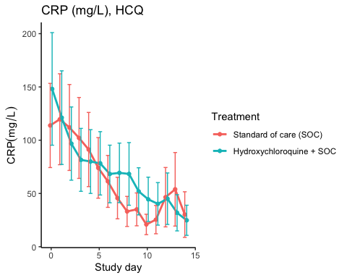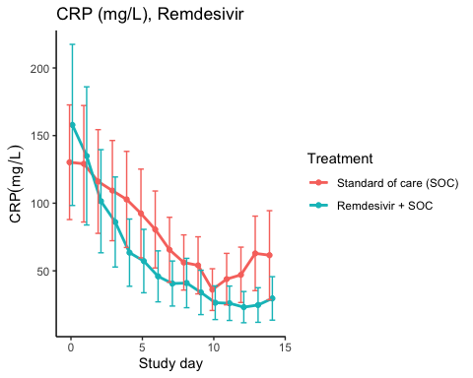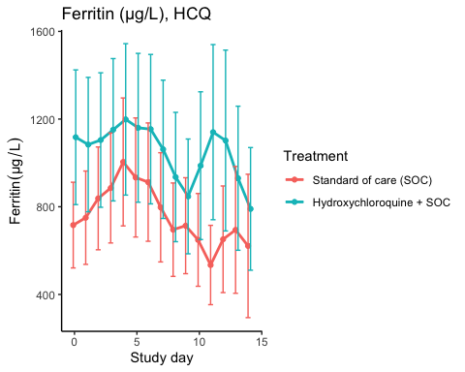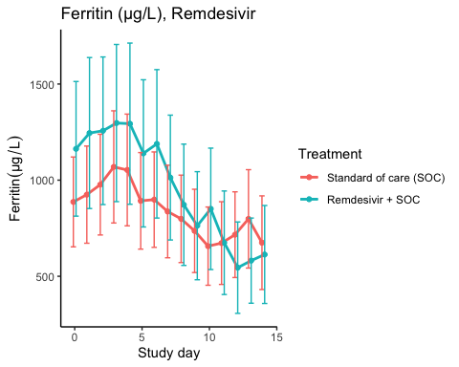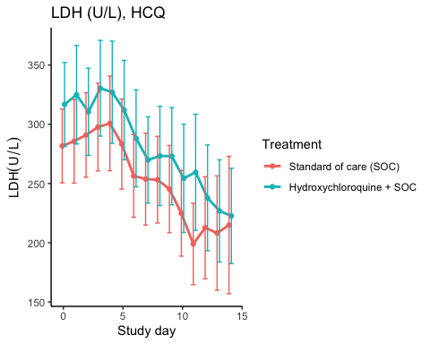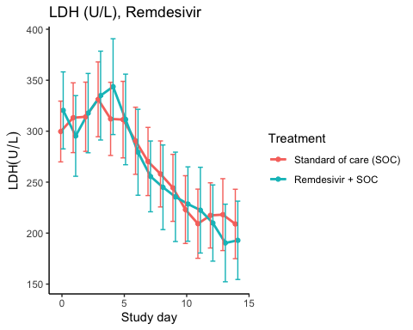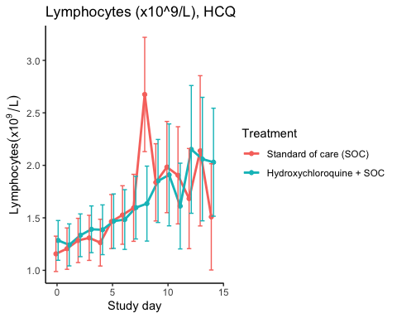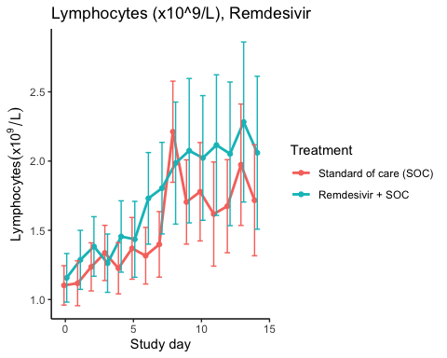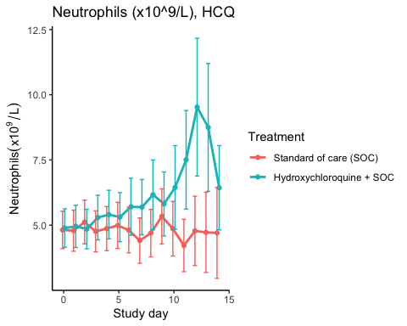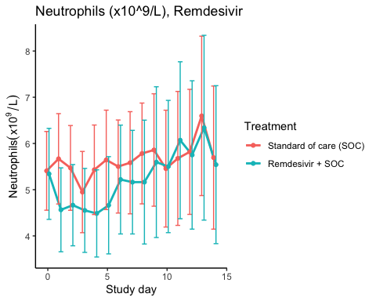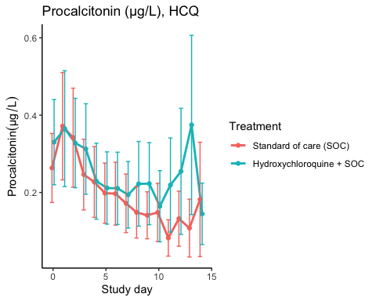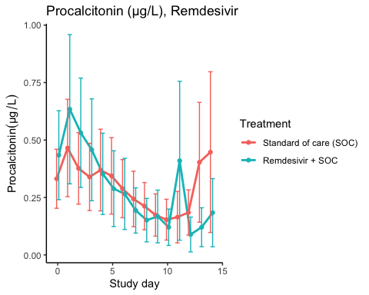

### Efficacy estimates

CRP (mg/L), HCQ

|  |  |  |  |  |  |
| --- | --- | --- | --- | --- | --- |
| Estimator | Treatment | Estimate | Lower 95% CL | Upper 95% CL | P-value |
| Slope 1st week by treatment | Standard of care (SOC) | -12.137 | -17.163 | -7.110 | 0.000 |
| Slope 1st week by treatment | Hydroxychloroquine + SOC | -9.267 | -13.581 | -4.953 | 0.000 |
| Difference in 1st week slope | Hydroxychloroquine + SOC | 2.870 | -3.248 | 8.988 | 0.358 |
| Day 10 level by treatment | Standard of care (SOC) | 38.049 | 24.883 | 51.216 | 0.000 |
| Day 10 level by treatment | Hydroxychloroquine + SOC | 45.755 | 29.943 | 61.568 | 0.000 |
| Day 10 treatment difference | Hydroxychloroquine + SOC | 7.706 | -11.335 | 26.748 | 0.428 |

CRP (mg/L), Remdesivir

|  |  |  |  |  |  |
| --- | --- | --- | --- | --- | --- |
| Estimator | Treatment | Estimate | Lower 95% CL | Upper 95% CL | P-value |
| Slope 1st week by treatment | Standard of care (SOC) | -10.175 | -14.413 | -5.938 | 0.000 |
| Slope 1st week by treatment | Remdesivir + SOC | -15.972 | -22.263 | -9.681 | 0.000 |
| Difference in 1st week slope | Remdesivir + SOC | -5.797 | -12.788 | 1.194 | 0.104 |
| Day 10 level by treatment | Standard of care (SOC) | 57.619 | 39.927 | 75.311 | 0.000 |
| Day 10 level by treatment | Remdesivir + SOC | 31.300 | 20.194 | 42.406 | 0.000 |
| Day 10 treatment difference | Remdesivir + SOC | -26.320 | -45.873 | -6.766 | 0.008 |

Ferritin (µg/L), HCQ

|  |  |  |  |  |  |
| --- | --- | --- | --- | --- | --- |
| Estimator | Treatment | Estimate | Lower 95% CL | Upper 95% CL | P-value |
| Slope 1st week by treatment | Standard of care (SOC) | 17.554 | 0.123 | 34.986 | 0.048 |
| Slope 1st week by treatment | Hydroxychloroquine + SOC | -5.469 | -25.492 | 14.554 | 0.592 |
| Difference in 1st week slope | Hydroxychloroquine + SOC | -23.023 | -49.598 | 3.552 | 0.090 |
| Day 10 level by treatment | Standard of care (SOC) | 698.297 | 506.292 | 890.301 | 0.000 |
| Day 10 level by treatment | Hydroxychloroquine + SOC | 997.752 | 722.018 | 1273.487 | 0.000 |
| Day 10 treatment difference | Hydroxychloroquine + SOC | 299.456 | -12.489 | 611.401 | 0.060 |

Ferritin (µg/L), Remdesivir

|  |  |  |  |  |  |
| --- | --- | --- | --- | --- | --- |
| Estimator | Treatment | Estimate | Lower 95% CL | Upper 95% CL | P-value |
| Slope 1st week by treatment | Standard of care (SOC) | -10.661 | -26.617 | 5.295 | 0.190 |
| Slope 1st week by treatment | Remdesivir + SOC | -21.849 | -46.510 | 2.812 | 0.082 |
| Difference in 1st week slope | Remdesivir + SOC | -11.188 | -40.370 | 17.994 | 0.452 |
| Day 10 level by treatment | Standard of care (SOC) | 779.953 | 578.299 | 981.607 | 0.000 |
| Day 10 level by treatment | Remdesivir + SOC | 798.289 | 559.139 | 1037.438 | 0.000 |
| Day 10 treatment difference | Remdesivir + SOC | 18.336 | -272.241 | 308.913 | 0.902 |

LDH (U/L), HCQ

|  |  |  |  |  |  |
| --- | --- | --- | --- | --- | --- |
| Estimator | Treatment | Estimate | Lower 95% CL | Upper 95% CL | P-value |
| Slope 1st week by treatment | Standard of care (SOC) | -3.473 | -6.964 | 0.018 | 0.051 |
| Slope 1st week by treatment | Hydroxychloroquine + SOC | -5.140 | -8.829 | -1.452 | 0.006 |
| Difference in 1st week slope | Hydroxychloroquine + SOC | -1.668 | -6.728 | 3.393 | 0.518 |
| Day 10 level by treatment | Standard of care (SOC) | 230.155 | 203.904 | 256.406 | 0.000 |
| Day 10 level by treatment | Hydroxychloroquine + SOC | 258.969 | 229.847 | 288.091 | 0.000 |
| Day 10 treatment difference | Hydroxychloroquine + SOC | 28.814 | -10.146 | 67.774 | 0.147 |

LDH (U/L), Remdesivir

|  |  |  |  |  |  |
| --- | --- | --- | --- | --- | --- |
| Estimator | Treatment | Estimate | Lower 95% CL | Upper 95% CL | P-value |
| Slope 1st week by treatment | Standard of care (SOC) | -4.028 | -7.059 | -0.997 | 0.009 |
| Slope 1st week by treatment | Remdesivir + SOC | -6.754 | -10.543 | -2.964 | 0.000 |
| Difference in 1st week slope | Remdesivir + SOC | -2.725 | -7.553 | 2.102 | 0.269 |
| Day 10 level by treatment | Standard of care (SOC) | 243.136 | 219.164 | 267.108 | 0.000 |
| Day 10 level by treatment | Remdesivir + SOC | 234.831 | 207.135 | 262.527 | 0.000 |
| Day 10 treatment difference | Remdesivir + SOC | -8.304 | -44.766 | 28.157 | 0.655 |

Lymphocytes (x10^9/L), HCQ

|  |  |  |  |  |  |
| --- | --- | --- | --- | --- | --- |
| Estimator | Treatment | Estimate | Lower 95% CL | Upper 95% CL | P-value |
| Slope 1st week by treatment | Standard of care (SOC) | 0.096 | 0.066 | 0.127 | 0.000 |
| Slope 1st week by treatment | Hydroxychloroquine + SOC | 0.047 | 0.020 | 0.075 | 0.001 |
| Difference in 1st week slope | Hydroxychloroquine + SOC | -0.049 | -0.090 | -0.008 | 0.018 |
| Day 10 level by treatment | Standard of care (SOC) | 1.858 | 1.577 | 2.138 | 0.000 |
| Day 10 level by treatment | Hydroxychloroquine + SOC | 1.785 | 1.522 | 2.048 | 0.000 |
| Day 10 treatment difference | Hydroxychloroquine + SOC | -0.073 | -0.447 | 0.301 | 0.702 |

Lymphocytes (x10^9/L), Remdesivir

|  |  |  |  |  |  |
| --- | --- | --- | --- | --- | --- |
| Estimator | Treatment | Estimate | Lower 95% CL | Upper 95% CL | P-value |
| Slope 1st week by treatment | Standard of care (SOC) | 0.075 | 0.052 | 0.099 | 0.000 |
| Slope 1st week by treatment | Remdesivir + SOC | 0.095 | 0.063 | 0.127 | 0.000 |
| Difference in 1st week slope | Remdesivir + SOC | 0.020 | -0.020 | 0.060 | 0.325 |
| Day 10 level by treatment | Standard of care (SOC) | 1.719 | 1.500 | 1.937 | 0.000 |
| Day 10 level by treatment | Remdesivir + SOC | 1.978 | 1.687 | 2.268 | 0.000 |
| Day 10 treatment difference | Remdesivir + SOC | 0.259 | -0.097 | 0.615 | 0.154 |

Neutrophils (x10^9/L), HCQ

|  |  |  |  |  |  |
| --- | --- | --- | --- | --- | --- |
| Estimator | Treatment | Estimate | Lower 95% CL | Upper 95% CL | P-value |
| Slope 1st week by treatment | Standard of care (SOC) | -0.009 | -0.091 | 0.073 | 0.829 |
| Slope 1st week by treatment | Hydroxychloroquine + SOC | 0.130 | 0.034 | 0.226 | 0.008 |
| Difference in 1st week slope | Hydroxychloroquine + SOC | 0.139 | 0.012 | 0.265 | 0.032 |
| Day 10 level by treatment | Standard of care (SOC) | 4.788 | 4.066 | 5.509 | 0.000 |
| Day 10 level by treatment | Hydroxychloroquine + SOC | 6.642 | 5.639 | 7.646 | 0.000 |
| Day 10 treatment difference | Hydroxychloroquine + SOC | 1.855 | 0.636 | 3.073 | 0.003 |

Neutrophils (x10^9/L), Remdesivir

|  |  |  |  |  |  |
| --- | --- | --- | --- | --- | --- |
| Estimator | Treatment | Estimate | Lower 95% CL | Upper 95% CL | P-value |
| Slope 1st week by treatment | Standard of care (SOC) | 0.021 | -0.072 | 0.114 | 0.661 |
| Slope 1st week by treatment | Remdesivir + SOC | 0.007 | -0.092 | 0.106 | 0.891 |
| Difference in 1st week slope | Remdesivir + SOC | -0.014 | -0.149 | 0.121 | 0.841 |
| Day 10 level by treatment | Standard of care (SOC) | 5.748 | 4.879 | 6.618 | 0.000 |
| Day 10 level by treatment | Remdesivir + SOC | 5.463 | 4.490 | 6.436 | 0.000 |
| Day 10 treatment difference | Remdesivir + SOC | -0.285 | -1.571 | 1.001 | 0.664 |

Procalcitonin (µg/L), HCQ

|  |  |  |  |  |  |
| --- | --- | --- | --- | --- | --- |
| Estimator | Treatment | Estimate | Lower 95% CL | Upper 95% CL | P-value |
| Slope 1st week by treatment | Standard of care (SOC) | -0.022 | -0.034 | -0.011 | 0.000 |
| Slope 1st week by treatment | Hydroxychloroquine + SOC | -0.022 | -0.036 | -0.008 | 0.002 |
| Difference in 1st week slope | Hydroxychloroquine + SOC | 0.000 | -0.017 | 0.018 | 0.983 |
| Day 10 level by treatment | Standard of care (SOC) | 0.141 | 0.093 | 0.188 | 0.000 |
| Day 10 level by treatment | Hydroxychloroquine + SOC | 0.216 | 0.144 | 0.287 | 0.000 |
| Day 10 treatment difference | Hydroxychloroquine + SOC | 0.075 | -0.007 | 0.157 | 0.073 |

Procalcitonin (µg/L), Remdesivir

|  |  |  |  |  |  |
| --- | --- | --- | --- | --- | --- |
| Estimator | Treatment | Estimate | Lower 95% CL | Upper 95% CL | P-value |
| Slope 1st week by treatment | Standard of care (SOC) | -0.024 | -0.042 | -0.006 | 0.007 |
| Slope 1st week by treatment | Remdesivir + SOC | -0.053 | -0.085 | -0.022 | 0.001 |
| Difference in 1st week slope | Remdesivir + SOC | -0.029 | -0.064 | 0.005 | 0.097 |
| Day 10 level by treatment | Standard of care (SOC) | 0.251 | 0.155 | 0.347 | 0.000 |
| Day 10 level by treatment | Remdesivir + SOC | 0.195 | 0.109 | 0.280 | 0.000 |
| Day 10 treatment difference | Remdesivir + SOC | -0.056 | -0.176 | 0.064 | 0.360 |

## SARS-CoV2 antibodies at day 90

### Descriptives

Hydroxychloroquine

|  |  |  |  |
| --- | --- | --- | --- |
| Outcome | Statistic | Standard of care (SOC) | Hydroxychloroquine + SOC |
| Receptor-bindind domain | Mean (SD) | 56.1 (46.9) | 66.5 (43.3) |
|  | Median (IQR) | 54 (11.3 - 90.4) | 57.2 (33.9 - 101.5) |
| Normalised receptor-binding domain | Mean (SD) | 16.6 (10.5) | 18.7 (11.5) |
|  | Median (IQR) | 15.7 (7.6 - 22.5) | 15.3 (11 - 25.6) |
| log10 ACE2 receptor-binding domain | Mean (SD) | 1.42 (0.63) | 1 (0.68) |
|  | Median (IQR) | 1.44 (1.18 - 1.8) | 0.94 (0.38 - 1.54) |

Remdesivir

|  |  |  |  |
| --- | --- | --- | --- |
| Outcome | Statistic | Standard of care (SOC) | Remdesivir + SOC |
| Receptor-bindind domain | Mean (SD) | 46.4 (37.2) | 60.5 (42.4) |
|  | Median (IQR) | 40.4 (11.3 - 70.3) | 57.4 (23.8 - 95.5) |
| Normalised receptor-binding domain | Mean (SD) | 15.4 (10.4) | 18.1 (11.8) |
|  | Median (IQR) | 15 (7 - 22.5) | 17.7 (9 - 26.4) |
| log10 ACE2 receptor-binding domain | Mean (SD) | 1.24 (0.7) | 1.2 (0.56) |
|  | Median (IQR) | 1.22 (0.78 - 1.73) | 1.24 (0.84 - 1.53) |

### Marginal probability estimates by treatment group and difference

Hydroxychloroquine

|  |  |  |  |
| --- | --- | --- | --- |
| Outcome | Standard of care (SOC) | Hydroxychloroquine + SOC | Estimated marginal treatment effect |
| Receptor-bindind domain | 56.1 (42.7 to 69.6) | 66.5 (51.9 to 81.1) | 10.4 (-9.4 to 30.3) |
| Normalised receptor-binding domain | 16.6 (13.3 to 19.8) | 18.7 (15.2 to 22.3) | 2.2 (-2.6 to 7) |
| log10 ACE2 receptor-binding domain | 1.42 (1.22 to 1.61) | 1 (0.79 to 1.21) | -0.42 (-0.71 to -0.13) |

Estimates are presented with 95% confidence limits

Remdesivir

|  |  |  |  |
| --- | --- | --- | --- |
| Outcome | Standard of care (SOC) | Remdesivir + SOC | Estimated marginal treatment effect |
| Receptor-bindind domain | 46.4 (35.7 to 57.2) | 60.5 (47.1 to 73.9) | 14 (-3.1 to 31.2) |
| Normalised receptor-binding domain | 15.4 (12.4 to 18.4) | 18.1 (14.3 to 21.8) | 2.7 (-2.1 to 7.5) |
| log10 ACE2 receptor-binding domain | 1.24 (1.06 to 1.41) | 1.2 (0.98 to 1.42) | -0.03 (-0.32 to 0.25) |

Estimates are presented with 95% confidence limits

## Time to last discharge

### HCQ

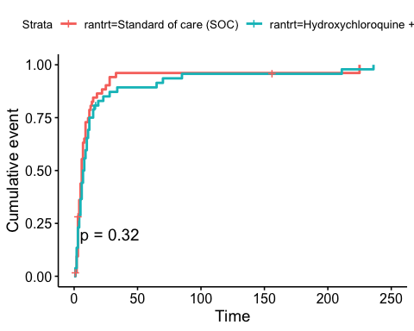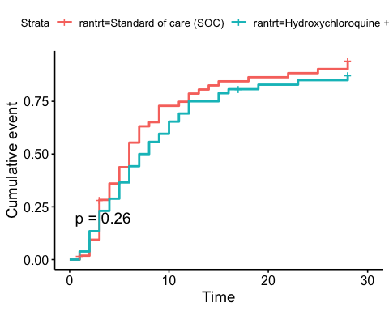

### Remdesivir

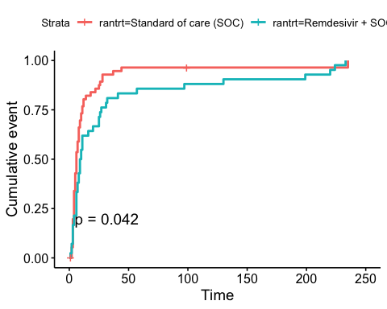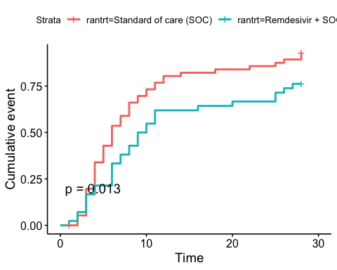

# Adverse Events

## AE Summary

Summary of Adverse Events

|  |  |  |  |
| --- | --- | --- | --- |
| Parameter | SOC (N=87) | SOC + HCQ (N=52) | SOC + Remdesivir (N=42) |
| Number of AEs | [31] 22 (25.3%) | [26] 17 (32.7%) | [36] 19 (45.2%) |
| Number of patients with any AEs? | 22 (25.3%) | 17 (32.7%) | 19 (45.2%) |
| Number of patients with one AE | 18 (20.7%) | 12 (23.1%) | 10 (23.8%) |
| Number of patients with two AE | 1 (1.1%) | 1 (1.9%) | 4 (9.5%) |
| Number of patients with three or more AEs | 3 (3.4%) | 4 (7.7%) | 5 (11.9%) |
| Number of SAEs | [15] 11 (12.6%) | [11] 9 (17.3%) | [19] 11 (26.2%) |
| Number of patients with any SAEs? | 11 (12.6%) | 9 (17.3%) | 11 (26.2%) |

The numbers are [Number of events] Number of patients (percentage of patients), or Number of patients (percentage of patients)

## By System Organ Class and Preferred Term

Adverse Events by System Organ Class and Preferred term

|  |  |  |  |  |
| --- | --- | --- | --- | --- |
| System Organ Class | Preferred Term | SOC (N=87) | SOC + HCQ (N=52) | SOC + Remdesivir (N=42) |
| Blood and lymphatic system disorders | #Total |  |  | [2] 1 (2.4%) |
|  | Leukopenia |  |  | [1] 1 (2.4%) |
|  | Thrombocytopenia |  |  | [1] 1 (2.4%) |
| Cardiac disorders | #Total | [1] 1 (1.1%) | [2] 1 (1.9%) | [1] 1 (2.4%) |
|  | Arrhythmia |  | [2] 1 (1.9%) |  |
|  | Ventricular tachycardia | [1] 1 (1.1%) |  | [1] 1 (2.4%) |
| Gastrointestinal disorders | #Total | [5] 5 (5.7%) | [4] 3 (5.8%) | [1] 1 (2.4%) |
|  | Abdominal pain | [1] 1 (1.1%) |  |  |
|  | Diarrhoea |  | [1] 1 (1.9%) |  |
|  | Diarrhoea haemorrhagic |  | [1] 1 (1.9%) |  |
|  | Gastrooesophageal reflux disease | [1] 1 (1.1%) |  |  |
|  | Intestinal pseudo-obstruction |  |  | [1] 1 (2.4%) |
|  | Nausea | [1] 1 (1.1%) | [1] 1 (1.9%) |  |
|  | Pancreatic failure | [1] 1 (1.1%) |  |  |
|  | Vomiting | [1] 1 (1.1%) | [1] 1 (1.9%) |  |
| General disorders and administration site conditions | #Total | [2] 2 (2.3%) | [1] 1 (1.9%) | [2] 2 (4.8%) |
|  | Chest pain |  |  | [1] 1 (2.4%) |
|  | General physical health deterioration | [1] 1 (1.1%) |  |  |
|  | Medical device site reaction |  |  | [1] 1 (2.4%) |
|  | Pyrexia | [1] 1 (1.1%) | [1] 1 (1.9%) |  |
| Hepatobiliary disorders | #Total | [1] 1 (1.1%) |  |  |
|  | Cholecystitis | [1] 1 (1.1%) |  |  |
| Infections and infestations | #Total | [1] 1 (1.1%) | [1] 1 (1.9%) | [3] 3 (7.1%) |
|  | COVID-19 | [1] 1 (1.1%) |  |  |
|  | Infection |  |  | [1] 1 (2.4%) |
|  | Pneumonia bacterial |  |  | [2] 2 (4.8%) |
|  | Superinfection bacterial |  | [1] 1 (1.9%) |  |
| Injury, poisoning and procedural complications | #Total | [1] 1 (1.1%) | [1] 1 (1.9%) |  |
|  | Hepatobiliary procedural complication | [1] 1 (1.1%) |  |  |
|  | Procedural pneumothorax |  | [1] 1 (1.9%) |  |
| Investigations | #Total | [4] 4 (4.6%) | [8] 5 (9.6%) | [7] 4 (9.5%) |
|  | Alanine aminotransferase increased |  | [4] 3 (5.8%) |  |
|  | Amylase increased |  |  | [1] 1 (2.4%) |
|  | Aspartate aminotransferase increased | [1] 1 (1.1%) | [2] 2 (3.8%) | [2] 2 (4.8%) |
|  | Blood creatine phosphokinase increased | [1] 1 (1.1%) |  |  |
|  | Electrocardiogram QT prolonged | [1] 1 (1.1%) |  | [1] 1 (2.4%) |
|  | Fibrin D dimer increased |  |  | [1] 1 (2.4%) |
|  | Gamma-glutamyltransferase increased |  |  | [1] 1 (2.4%) |
|  | Hepatic enzyme increased |  | [2] 2 (3.8%) |  |
|  | Myocardial necrosis marker increased | [1] 1 (1.1%) |  |  |
|  | Neutrophil count decreased |  |  | [1] 1 (2.4%) |
| Metabolism and nutrition disorders | #Total |  | [1] 1 (1.9%) |  |
|  | Hypercalcaemia |  | [1] 1 (1.9%) |  |
| Musculoskeletal and connective tissue disorders | #Total | [4] 2 (2.3%) |  |  |
|  | Arthralgia | [1] 1 (1.1%) |  |  |
|  | Arthritis reactive | [1] 1 (1.1%) |  |  |
|  | Joint swelling | [1] 1 (1.1%) |  |  |
|  | Tendonitis | [1] 1 (1.1%) |  |  |
| Neoplasms benign, malignant and unspecified (incl cysts and polyps) | #Total |  |  | [1] 1 (2.4%) |
|  | Neoplasm malignant |  |  | [1] 1 (2.4%) |
| Nervous system disorders | #Total | [1] 1 (1.1%) | [2] 2 (3.8%) | [2] 2 (4.8%) |
|  | Haemorrhage intracranial |  | [1] 1 (1.9%) |  |
|  | Headache |  |  | [1] 1 (2.4%) |
|  | Loss of consciousness |  |  | [1] 1 (2.4%) |
|  | Syncope | [1] 1 (1.1%) | [1] 1 (1.9%) |  |
| Renal and urinary disorders | #Total | [1] 1 (1.1%) |  | [1] 1 (2.4%) |
|  | Renal failure | [1] 1 (1.1%) |  | [1] 1 (2.4%) |
| Respiratory, thoracic and mediastinal disorders | #Total | [8] 7 (8%) | [5] 5 (9.6%) | [14] 9 (21.4%) |
|  | Bronchopleural fistula |  |  | [1] 1 (2.4%) |
|  | Chronic obstructive pulmonary disease |  |  | [2] 1 (2.4%) |
|  | Cough |  |  | [1] 1 (2.4%) |
|  | Dyspnoea | [1] 1 (1.1%) |  | [3] 1 (2.4%) |
|  | Pulmonary embolism | [1] 1 (1.1%) |  |  |
|  | Respiratory distress | [4] 4 (4.6%) | [1] 1 (1.9%) | [3] 2 (4.8%) |
|  | Respiratory failure | [2] 2 (2.3%) | [4] 4 (7.7%) | [4] 3 (7.1%) |
| Skin and subcutaneous tissue disorders | #Total |  | [1] 1 (1.9%) | [1] 1 (2.4%) |
|  | Alopecia |  | [1] 1 (1.9%) | [1] 1 (2.4%) |
| Vascular disorders | #Total | [2] 2 (2.3%) |  | [1] 1 (2.4%) |
|  | Hypotension |  |  | [1] 1 (2.4%) |
|  | Thrombophlebitis | [1] 1 (1.1%) |  |  |
|  | Thrombosis | [1] 1 (1.1%) |  |  |

## Serious Adverse Events

Serious Adverse Events by System Organ Class and Preferred term

|  |  |  |  |  |
| --- | --- | --- | --- | --- |
| System Organ Class | Preferred Term | SOC (N=87) | SOC + HCQ (N=52) | SOC + Remdesivir (N=42) |
| Gastrointestinal disorders | #Total | [1] 1 (1.1%) | [1] 1 (1.9%) |  |
|  | Abdominal pain | [1] 1 (1.1%) |  |  |
|  | Diarrhoea haemorrhagic |  | [1] 1 (1.9%) |  |
| General disorders and administration site conditions | #Total | [2] 2 (2.3%) |  | [1] 1 (2.4%) |
|  | Chest pain |  |  | [1] 1 (2.4%) |
|  | General physical health deterioration | [1] 1 (1.1%) |  |  |
|  | Pyrexia | [1] 1 (1.1%) |  |  |
| Hepatobiliary disorders | #Total | [1] 1 (1.1%) |  |  |
|  | Cholecystitis | [1] 1 (1.1%) |  |  |
| Infections and infestations | #Total | [1] 1 (1.1%) | [1] 1 (1.9%) | [1] 1 (2.4%) |
|  | COVID-19 | [1] 1 (1.1%) |  |  |
|  | Pneumonia bacterial |  |  | [1] 1 (2.4%) |
|  | Superinfection bacterial |  | [1] 1 (1.9%) |  |
| Injury, poisoning and procedural complications | #Total | [1] 1 (1.1%) | [1] 1 (1.9%) |  |
|  | Hepatobiliary procedural complication | [1] 1 (1.1%) |  |  |
|  | Procedural pneumothorax |  | [1] 1 (1.9%) |  |
| Investigations | #Total | [1] 1 (1.1%) | [3] 3 (5.8%) | [1] 1 (2.4%) |
|  | Alanine aminotransferase increased |  | [1] 1 (1.9%) |  |
|  | Aspartate aminotransferase increased |  |  | [1] 1 (2.4%) |
|  | Blood creatine phosphokinase increased | [1] 1 (1.1%) |  |  |
|  | Hepatic enzyme increased |  | [2] 2 (3.8%) |  |
| Neoplasms benign, malignant and unspecified (incl cysts and polyps) | #Total |  |  | [1] 1 (2.4%) |
|  | Neoplasm malignant |  |  | [1] 1 (2.4%) |
| Nervous system disorders | #Total |  | [1] 1 (1.9%) | [1] 1 (2.4%) |
|  | Haemorrhage intracranial |  | [1] 1 (1.9%) |  |
|  | Loss of consciousness |  |  | [1] 1 (2.4%) |
| Renal and urinary disorders | #Total | [1] 1 (1.1%) |  | [1] 1 (2.4%) |
|  | Renal failure | [1] 1 (1.1%) |  | [1] 1 (2.4%) |
| Respiratory, thoracic and mediastinal disorders | #Total | [7] 6 (6.9%) | [4] 4 (7.7%) | [13] 8 (19%) |
|  | Bronchopleural fistula |  |  | [1] 1 (2.4%) |
|  | Chronic obstructive pulmonary disease |  |  | [2] 1 (2.4%) |
|  | Dyspnoea | [1] 1 (1.1%) |  | [3] 1 (2.4%) |
|  | Pulmonary embolism | [1] 1 (1.1%) |  |  |
|  | Respiratory distress | [3] 3 (3.4%) | [1] 1 (1.9%) | [3] 2 (4.8%) |
|  | Respiratory failure | [2] 2 (2.3%) | [3] 3 (5.8%) | [4] 3 (7.1%) |

## Suspected Unexpected Serious Adverse Reaction

Suspected Unexpected Serious Adverse Reaction by System Organ Class and Preferred term

|  |  |  |
| --- | --- | --- |
| System Organ Class | Preferred Term | Hydroxychloroquine + SOC |
| Gastrointestinal disorders | #Total | [1] 1 (1.9%) |
|  | Diarrhoea haemorrhagic | [1] 1 (1.9%) |

END